A Fuzzy Inference System for Education

A way to grade the tech education system for girls, girls of colour, trans and girls+

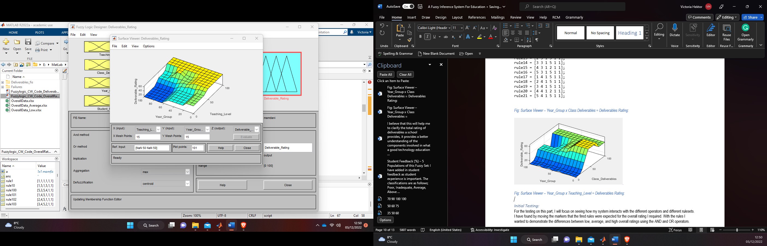

# Abstract

In this report I will bring to life a new way to look at how we rate our technology education system for young girls+, from the student perspective and the learning environment. Right now, we have Ofsted to provide school ratings using a combination of fuzzy and crisp information that provides an overall evaluation of schools performance. As it stands, there is a huge skills gap, that has gone unfulfilled for many years, we cannot teach and train enough students within tech to fill this urgent need. In addition to this, women+ in general are majorly underrepresented in the tech industry so the initial research will be focused on the technology education area for 11–17-year-olds. To finalise, I hope to bring to the forefront the importance of tech education in younger age groups and propose a plan to combat the inadequacy in technology education today.

My system will be making use of the Mamdami type fuzzy inference system, as well as the MatLab Designer to prototype the system. This report will detail my journey on creating this system along with critical reflection and future prospects. It is within the brief of no more than twelve pages for the main report with appendices at the end after the bibliography.

Contents

Abstract 1

Figures 3

Introduction 4

Review of Current Systems and Literature 4

Existing Systems Review 4

Existing Research and Literature 5

Overview of Problem & My Approach 6

Technical Description 7

Input Variables: 8

Output Variable: 8

Implication Operator Choice: 9

Rulesets: 9

Experimental Design & Evaluation 9

The Fuzzy Designer 9

The System Design 9

The Journey 10

Experimenting with outputs according to year group 11

Critical Reflection 12

Future Research & Prospects 13

Conclusion 14

Bibliography 15

Appendices 17

Appendix A - TechEducationOverall – Surface Viewers – Plots & Line Graphs 17

Appendix B – Rules and Tables 22

Appendix C – Testing 24

# Figures

Figure1. Teaching Level Membership Function 17

Figure2. Class Deliverables Membership Function 17

Figure3. Year Group Membership Function 17

Figure4. Student Feedback Membership Function 18

Figure5. Deliverable Rating Output Membership Function 18

Figure6. Surface Viewer – Year_Group x Class Deliverables = Deliverables Rating: 18

Figure7. Surface Viewer – Year_Group x Teaching_Level = Deliverables Rating: 19

Figure8. Surface Viewer – Student_Feedback x Class Deliverables = Deliverables Rating: 19

Figure9. Surface Viewer – Student_Feedback x Teaching_Level = Deliverables Rating: 19

Figure10. Surface Viewer – Student_Feedback x Year_Group = Deliverables Rating: 19

Figure11. Surface Viewer charts for the inputs and output of my fis. 20

Figure12. Education Rating, as designed using the Fuzzy Designer. 20

Figure13. Overall Deliverables Rating x Degree of Membership 20

Figure14. Full overview of Inputs and Outputs for my fis 21

Table3. - Rules for the main chunk of testing 22

Table4. – Rules for further testing all methods 22

Table5. What Ofsted Looks at (Ofsted) 22

Table6. Ofsted Grading Criteria Breakdown: 23

Table7. – Rules for further testing (AND, OR, Min, Max, Centroid) 23

Figure15. Excel Depiction of Year Group 7 Testing 24

Figure16. Poor Rating Ruleset Graph – Min, Max 24

Figure17. Poor Rating Ruleset Graph – Prod, Probor 24

Figure18. Complete overall graph depicting all initial testing on my first system. 25

Figure19. 12-14% Bisector, Centroid & MoM Output, Min, Max 25

Figure20. LoM Output, Min, Max 25

Figure21. SoM Output, Min, Max 26

Figure22. Centroid – Prod, Probor 26

Figure23. MoM – Prod, Probor 26

Figure24. LoM – Prod, Probor 26

Figure25. SoM – Prod, Probor 27

Figure26. Bisector – Prod, Probor 27

Figure27. Additional Testing Outcome 27

Figure28. Final Overall Testing – Low Groups (21%) 27

Figure29. Final Overall Testing – 10 Rules (57%) 28

Figure30. Final Overall Testing – 10 Rules (35%) 28

Figure31. Final Overall Testing – 10 Rules (76%) 28

Figure32. Final Overall Testing – 10 Rules, Min, Max, Centroid (46.2%) 28

Figure33. Final Overall Testing – 10 Rules, Min, Max, MoM (95%) 29

Figure34. Final Overall Testing – 10 Rules Min, Max, LoM 65%) 29

Figure35. Final Overall Testing – 10 Rules, Min, Max, SoM (50%) 29

Figure36. Final Overall Testing – 10 Rules Min, Max, Bisector (54%) 29

Figure37. Final Overall Testing – 32 Rules: Min, Max, Centroid 30

Figure38. Final Overall Testing – 32 Rules: Min, Max, MoM 30

Figure39. Final Overall Testing – 32 Rules: Min, Max, LoM 30

Figure40. Final Overall Testing – 32 Rules: Min, Max, SoM 31

Figure41. Final Overall Testing – 32 Rules: Min, Max, Bisector 31

Figure42. Centroid – **Cen**tre of an object MOM, SOM, and LOM stand for middle, smallest, and largest of maximum (Output Representation) 31

# Introduction

A call for STEM Equity; Todays’ education system is not faring well in the STEM sectors, more and more teachers are leaving the teaching profession, seeking a role that pays more, and offers more incentive and less stress. Sibieta (2020) This has a huge knock-on effect on young peoples’ early years, and can be extraordinarily detrimental, but not just to the student education experience; British Science Association(2020) speaks with Vanessa Maddu about her experience, who explains that the lack of Computer Science education in her early school life almost prevented her from finding her passion, computing and coding. This message is clear through any and all literature that I am finding, there is not enough specialist teachers in the STEM subjects, not enough tech education, and there is great inequity among many students that have protected characteristics, including women, women of colour, trans women, and non-binary.

With this system I aim to turn the fuzzy information that surrounds our education system for girls+ (Women+) and the impact it has on students and turn it in to a crisp value, to enable quantification of a sector that is struggling, and to potentially allow for positive action and change. Secondary education needs a shake-up, The All-Party Parliamentary Group (APPG)(2020) damning report shows just how much inequity in education impacts disadvantaged groups, noting the impact that poor equity has on the skills gap within STEM sectors and the issues it creates in wider society. The report also found that as children progressed, the more inequity prevailed, being more pronounced around GCSE age “and beyond”.

With such turmoil surrounding the lack of education in technology, and no clear path to evolve our education system for the youth of tomorrow, I aim to address the stark differences between advantaged and disadvantaged students, to better understand the ongoing inequity among the students of today, which will hopefully push schools to flip STEM education on its head and come at it from a different angle, the current system isn’t working and consistently lets down disadvantaged youths, women, non-binary, and women+ of colour, this fuzzy inference system will take the different perspectives and their degree of membership to the many aspects of education, and combine it with logic to determine whether or not our schools are providing a sustainable, inspiring and encouraging tech education to all of the youth of today.

To conclude this section, this system will allow interpretation in the format of a true or false output to a degree of membership for each of my set variables to decide at what level a school is performing in their delivery of tech education for young girls+. The data used in the initial experimentation will be test data and will be processed through my fis with a desired outcome of being able and armed to address how tech education impacts young girls+ of today, how this ties in with the gender gap, and addresses the skills gap.

The system will be encapsulated using MatLab, and I will be making use of .M files with excel to aid in visualising the systems and the testing stages. The data I will be using for the systems will be test data as using real-world data at this point will need an ethics application of some kind.

# Review of Current Systems and Literature

## Existing Systems Review

Currently there is only one quantifying way to rate schools, Ofsted (2022). I am using this real-world example initially to demonstrate what I am aiming for in my system, as there is not specific system that is exactly like what I am proposing, I will give both a review of similar educational rating tools, and fuzzy logic in education generally. Ofsted reports directly to the government and provides an overall grading of the schools, and other learning environments, that it visits under the various inspections they carry out. For each section, there will be supporting written reports from the inspectors to support the grade given, this is entirely at the inspector's discretion and relies on an individual’s perspective in making the decision on the grade a school will receive on the given subjects (See Table 5, Appendix B)

From this perspective, it seems that the grading system requires a judgement from someone on each of the above subjects, thus making it somewhat of a fuzzy logic system. Everything is perspective, which can change

depending on many variables, including but not limited to; having a good or bad day, not liking the people you are talking to, or the scenario/situation/presentation doesn’t fit in with the ideals that a person may hold. All of these things can impact someone’s judgement, we are human after all. Some of the components of the Ofsted system are decided by crisp values, such as grades. There is a broader set of 4 inspection judgements which focus predominantly on the “Quality of education” as opposed to relying on grades. The Key(2022)

An additional note here, the system I am proposing takes a more granular look at the Technology Education that girls+ receive at various stages in the education from aged 11 to aged 17 and will have similar inference from different aspects of the education setting and its students. (See Table6, Appendix B)

## Existing Research and Literature

Looking at the current literature for educational fuzzy inference systems (fis) has shed some interesting light on this subject. There is not yet a fis for rating tech education for young girls+ aged 11-17. There are many that base their fis on student performance analysis, portfolio assessment, and higher education. As there is no exact system to what I am proposing that utilises Fuzzy Logic, and MatLab, I will take a look at the literature on Fuzzy Logic in Education.

The idea behind Fuzzy Logic, is to enable extrapolation of information that can perceived differently by whomever perceives it, and turn this into quantifiable information, in effect, taking the vague, uncertain and imprecise things of this world and create logic from it. There is a rich history of what is now widely known as ‘Fuzzy Logic’, dating back to as early as 428-347 B.C. Garrido(2012), that being said, there are many noteworthy contributors of Fuzzy Logic research, Bertrand Russell, and the most recent “father of Fuzzy Logic” Garrido also posits that Lofti A. Zadeh, who initially was greeted with a dismissive reception of his work, which is now widely perceived as innovative with many continuing his research and theories.

Martinez-Vazquez (2018) has created a system that visualises higher education and in one section looks at the degrees of membership between curriculum and professional standards. Finding that more is needed to prepare students for the professional world and recommends an engagement component to industry to mitigate the gaps perceived. Using inputs consisting of ‘student performance and satisfaction, employability, and degree classification’ in the hopes of revealing gaps, monitor effectiveness and the quality of teaching. I plan to implement Martinez-Vazquezs’ ideas around utilising student performance and satisfaction within my fis and believe this will help students focus on taking a more controlled and responsible ownership of their education.

Cervero et al (2020) offers an insightful way to look at how the latest virtual learning environments impact students. They take into account the student experience and use fuzzy logic to output a readable result. I like the idea that this is focused on student experience and will utilise some of their methodology to critically reflect on my system. I have found during my research stage that most educational fuzzy logic systems are designed for post-school education, predominantly university era, which brings me back to focus, how can we change the developing issue of the skills gap, and how can we critically address the gender gap within technology based careers, we must start looking at what the root cause could be and build on that.

Sobrino (2013) proposed bring Fuzzy Logic into secondary school education and to be taught alongside Logic, an interesting proposition to encompass Mathematics and Philosophy, two great areas of study. The idea of teaching Fuzzy Logic within secondary school could bring about a huge positive impact on students by way increasing their critical thinking skills alongside common sense reasoning and inference. For the purpose of my system this paper helps to make my case regarding education for young girls+, there are many new and innovative technologies around, like deep learning and Artificial intelligence, and Fuzzy Logic will help to foster potential in future AI and Deep Learning Experts and innovators. Sobrino manages to position his argument from the aspect of, students will have come across ‘fuzzy logic’ in their everyday lives, and more than likely will have undertaken some form of argumentation on a fuzzy subject that impassions them. The reasonable conclusion; provide stimulating examples and students shall participate. A very noteworthy mention here to Dr Archie Singh Khuman who has provided a fine example of of a stimulating example; he has given his Fuzzy Logic students free reign to explore the area of Fuzzy Logic and provide a system that fits in to their passions using the basis of Fuzzy Logic.

# Overview of Problem & My Approach

According to Kemp, Palmer, and Strelen(2019), 38% of schools do not offer Computer Science as a GCSE with evidence showing that poorer areas are affected by this negatively compared to their affluent counterparts. There are so many aspects to education that lines are blurred, and information is fuzzy and crisp, I plan to create a system that will extrapolate relevant information and analysis of data to present in a way that encourages a positive move forward in the technology education of young girls+. For my proposed fis, I have decided that there are four aspects to a young girls+ technology based learning and those are a combination of the teaching levels, class deliverables, feedback and age group.

The idea behind this fuzzy inference system is to quantify the quality of education for young girls to enable a critical review of the education they are receiving to see if this is having a knock-on effect on whether they choose tech-based subjects going into 6th form, college, and university. This could be a tool for educators to evaluate their quality of education being delivered on a school/ground level and would support plan implementations to improve quality and support positive change. In effect, a control method to quantify individual schools' performance of their own technology-based education that will identify the degrees of membership of which fuzzy set has the with the other and what affect this has on the outcome.

As it stands, some schools are not offering an adequate level of tech education for girls+, couple this with the skills gap and gender gap within the tech industry, shows the poor level of education that girls+ are receiving, and the impact of a poor education on the youth of today. The aim is to get more technology related subjects at a younger age taught in schools, and also to bring in ICT/Computer Science as a core subject alongside English, Maths and Science.

My approach will be to take certain information from schools, which detail their ICT/Computer Science Curriculum, allowing me to view this teaching perspective, in addition to this, I would speak with educators of tech-based subjects, and look at the lesson plans and deliverables to establish what grade students are working at and what level they are being taught. At this stage I want to bring in student ages and their feedback on tech education.

Knowing the amount of times a computing based class occurs each week will allow me to compare that to various other schools and the national average of technology subjects being taught, my research has shown me that currently there is a shortage of Computer competent teachers, due to many factors, including pay, workload and the fact that tech based roles in sector pay a lot more than being a teacher does. This causes a gap in teaching in the tech education sector. This input variable will help me to identify schools that could be limited in how often they deliver tech based learning. it may even look different among the varied age groups. It will also allow schools to evaluate, plan and implement changes for a positive impact on young girls+ futures.

Class length and occurrence are variables that wouldn’t necessarily cause any great observations in most cases, but it will help to identify the amount of time that’s being spent teaching and learning. It will also come in handy for monitoring external/extra-curricular activities which will be included as long as they are tech based. It would also be interesting to view class length and compare this to the class occurrence and see if there’s any deviation between schools in the way they deliver this.

The deliverables are an important and integral part of my fis, allowing me to identify low performing areas in relation to tech education, this will help to evolve an in-depth look at why an age group is under-performing compared to their counterparts? Is it staff shortage, materials/hardware, budget, or locality. It will also help to identify at what level the different age groups are studying at. This variable takes on the teaching level which is encompassed with lesson content and has the potential to produce a second fis based entirely on the teaching/learning aspect.

Students are in a position where they do not take responsibility for their learning until they reach early adulthood, having an option to feedback and propose ideas will engage students in a way that will help them to be present in learning activities and think deeply about the education they receive. There are a couple of ways to ask for feedback, initially it is based around agree/disagree on simple questions based on their tech education. This could be evolved into asking whether or not they understand the teaching being delivered and asking for their input on what they would like to learn about. On my own education journey, I have only ever been asked feedback when I attended university and think this should change to help bring about ownership and pride in education at all age levels. Student age is an important factor and allows for identification of under-performance and likewise, high achieving age groups. The weight for this variable can be reduced and is something I will experiment with.

I took an approach initially of two systems with the first monitoring the deliverable side of education, taking into account the variables; Teaching Level, Class Occurrence, and Class Length. The output will then make up the Deliverables input section of my second system, Overall Rating (of Tech Education for Girls+) along with the variables; Student Feedback, and Student Year Group. After testing it out with some rules and critical review, it did not offer ‘fit for purpose’. I managed to condense the system to one, having four variables and one output which produced a verifiable system to infer information from.

To round off my thinking on the approach I am taking; I feel that education can be stifling for some students and it needs a positive overhaul to be inclusive of individual students, the education being taught today is not representative of today’s world that young children are growing up in. A school may well be graded Good by Ofsted, but does their technology based delivered education to the different year groups represent a comprehensive and holistic tech learning journey for its students.

Another consideration that I feel is important in today’s world is the holistic approach to learning, well-being, and overall educational journey, and taking a look at how modern day education feeds into today’s world, into the world of work, and students potential. I am passionate about highlighting accessibility for all students,

I am a believer of everything is interdependent here, thus I am taking the view that Teaching Level interdepends on Class Deliverables, Student Feedback, with Student Year Group being interdependent on Teaching Level. This classification is important due to needing to clarify at what level is classed as suitable for each year group, and how do we classify this in a way that could be understood and simply demonstrated. Class Deliverables are a huge aspect to overall grading percentage and encompasses the timescales of the Teaching provided at schools, it will also help to identify if a school is under-performing at any level, which will then allow an approach of, how can we fix this.

# Technical Description

After much testing and experiments on my initial single fis, I discovered my initial system was not representing the desired output, I have since changed the system and amended the inputs to reflect what I want the system to show. Splitting the fis into two separate fis’s initially allowed me to have separation of concerns while still utilising the output from the first system as an input to my second system, but I with time constraints I felt I could not produce a system that I was happy with, so I created a system with four inputs and one output under the premise that Class Deliverables had already been calculated via another fis and fed into my Class Deliverables Membership Function, that Student Feedback had also been created and collated in another fis based solely on questions asked of the students focused on their education, and fed in to my system. Teaching Level and Student Year Group are more definable variables as the current system for teaching levels is already in place and the age groups generally have a set time of year for groupings of age, side note; there may well be an exception here, should a younger student progress quicker through their education, or should a student have to resit a year for whatever reason. I experimented a lot with the membership functions and chose predominantly triangular and trapezoidal membership functions. (See figures 1-14 for the system design, Appendix A)

Formulas [1] (Trapezoidal, Triangular respectively):

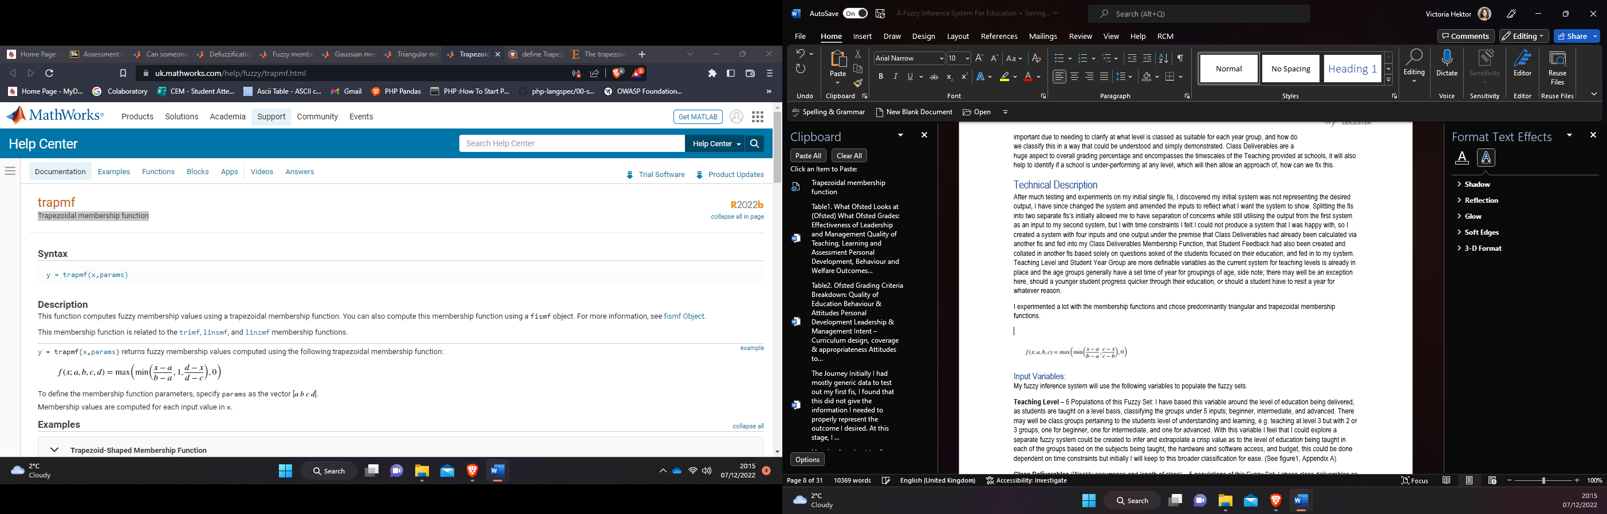

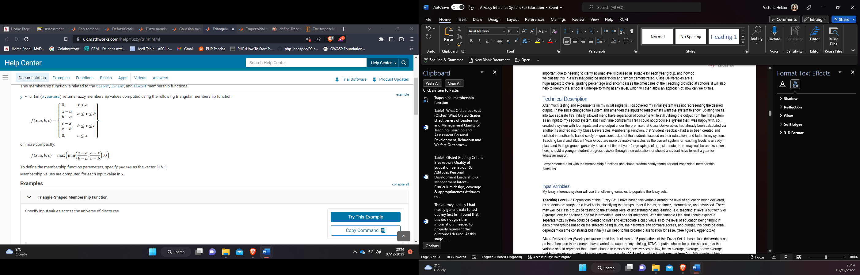

## Input Variables:

My fuzzy inference system will use the following variables to populate the fuzzy sets.

**Teaching Level** – *5 Populations of this Fuzzy Set*: I have based this variable around the level of education being delivered, as students are taught on a level basis, classifying the groups under 5 inputs; beginner, intermediate, and advanced. There may well be class groups pertaining to the students level of understanding and learning, e.g. teaching at level 3 but with 2 or 3 groups, one for beginner, one for intermediate, and one for advanced. With this variable I feel that I could explore a separate fuzzy system could be created to infer and extrapolate a crisp value as to the level of education being taught in each of the groups based on the subjects being taught, the hardware and software access, and budget, this could be done dependent on time constraints but initially I will keep to this broader classification for ease. (See figure1, Appendix A)

**Class Deliverables** *(Weekly occurrence and length of class) – 5 populations of this Fuzzy Set*: I chose class deliverables as an input because the research I have carried out supports my thinking, ICT/Computing should be a core subject thus the variable should represent that. I have chosen to classify the occurrences as low, below average, average, above average and high, which represents class occurrence on a scale of 0-5 and the class length ranging from 0 to 240 minutes. I have chosen to keep 0 in as a value because this will allow proper evaluation of delivery in schools, a 0 will highlight any major problems and go some way to identify issues, for example, lack of computer teachers, and lack of technology on site. This could then allow for resolution of any potential issues. It will also identify leading technology educators and could be a desirable tool for parents. (See figure2, Appendix A)

**NB:** I have chosen to include extra-curricular Computing clubs/groups etc within the class occurrence and length, I feel self-teaching/learning is an excellent form of education, and if a student has taken this direction offered by the school as additional activities, it rightly should impact the schools overall grading.

**Student Year Group** – *5 Populations of this Fuzzy Set*: This variable is an experimental one for my system, I am not entirely sure on how this will impact the outcome, but I am hoping it can be used as a tool to identify lack in any taught year groups, for example, are year 9’s being taught at a level that is inadequate for their age range? Or on the other side of the spectrum, are there any outstanding schools delivering advanced computer science to their students above the average age ranges? For example, advanced computer science being taught to year 9’s when the norm is intermediate for this age group. This is a more specific variable and I will use test cases to demonstrate how this system would potentially identify these areas. (See figure3, Appendix A)

**Student Feedback** (%) – *5 Populations of this Fuzzy Set*: I have added in student feedback as student experience is important. The classifications are as follows; Poor, Inadequate, Average, Above Average, and Excellent. I have created a set of questions to demonstrate what will be asked of students and how they will answer. The grading will be on a scale of 1-10. This variable should be able to demonstrate a student’s understanding of their own education and what it is providing them in relation to exploring their existing talent and future potential. It is also here to potentially engage students in a way that is not the norm and may help students think about their learning in a different light, I am also hoping that this will hold students accountable in a positive way for their own learning journey. (See figure4, Appendix A)

## Output Variable:

**Overall Tech Education Grade** (%) – *5 Populations*: For the output there are 5 levels of grading which are a combination of all of the inputs detailed above. This will classify and rate a schools technology education within the following groups; Poor, Below Average, Average, Above Average and Exceptional. This will be based on a percentage (%).

I believe that this will help me to clarify the total rating of the education a school provides to my chosen representative field of girls+ aged 11-17, it provides a better understanding of the components involved in what a good technology education looks like and dives into the fuzzy information surrounding the current delivery, and how often and how long tech education is being taught. (See figure5, Appendix A)

## Implication Operator Choice:

I will experiment with both **AND** and **OR**, and also **NOT (¬)** there are no cases where the inference does not have to be fully inclusive of my inputs. With my system I feel the **AND** operator will be more intuitive of the desired output, that being said, I will experiment with both operators. With this system, the important takeaway is that all of the inputs matter to a certain degree, thus meaning all of them must play a part in the outcome.

## Rulesets:

I have designed several test with varying sets of rules (See appendix B) to test my system and the premise that I am proposing in this report. I will experiment with large rulesets, small rulesets and logical rulesets that make sense of my systems membership functions. Throughout the report you will see varying degrees of my journey along with some bright and wonder representations of the system design, as well as the testing of my rules, hot tip; the best experimentations happened towards the end, the end of Appendix C Figures 29-42) will offer much better viewing.

Here it is also noteworthy to mention that should a school be delivering advance teaching to its students but offering little time by way of classroom based learning for the students to comprehend the teaching, then this should be considered as a poor rating. On the opposite side of the scale, if the teaching deliverables is beginner at year 10 or 11 and has any class deliverable, this would also be classified as poor due to the teaching level not fitting in with the age group. I must also mention for neurodivergent students, the levels may look different from this perspective and this is something that can be looked into as maybe an additional system to classify students learning grades dependent more on their capabilities than their academia levels.

*(See Appendix B for the Rulesets)*

I initially will test the rules from the perspective of the Year_Group, and later on, switch focus to the output. I feel it is important to explore as much as possible with this system and have made many changes as things progressed.

# Experimental Design & Evaluation

Here I will go through several steps to create my ideal system, initially I attempted one system, then two systems, but it did not have the desired outcome, I have since evolved my system into one with four inputs and one output.

## The Fuzzy Designer

### The System Design

The initial system did not give me what I desire, I rethought and redesigned the system, simplifying and in essence creating a more elegant system. The main change came from combining the two class variables in to one variable. Class Rating as a % determining overall Class Deliverable Rating. (See Appendix A) I also wanted to reduce the inputs but also capture the output I was seeking using the information I had proposed.

*There is a total of 115 rules that I experimented with, some worked, and some didn’t. (experimentation details in Appendices A, B, & C. + EducationData and EducationData_1 Spreadsheet)*

The idea behind this system is to define the idea of Low, Below Average, Average, Above Average and High within an educational setting, for example, if the teaching level was low, and the class rating was low, within any year group, then the overall rating would be considered as poor. An example of average could be, if the teaching level is at average and class deliverables is average or high, for year groups 7 to 9, the rating would be classified as average, for years 10 and 11, this should be considered below average and poor respectively. For demonstrating an excellent rating, teaching level must be advanced and coupled with either average or higher on class deliverables, this is for year groups 9 to 11. I feel This way of designing my fis will be successful and emulate the desired fis that I can see in my mind.

At this stage of experimentation and design, I am able to clearly see what I would use the system for, I am creating an online learning platform aimed at young girls+ for my final year project and I would want to see the system I have created as a built-in online tool for educators to use to be able to model their future tech education for the youth of tomorrow. I would also want to ensure that this system is for all genders but have the option to define the input by gender. It would also be interesting to see if there is any difference in gender representation in tech at secondary school level. Food for thought and an experiment for another day.

#### Initial Testing:

For the testing on this part, I will focus on seeing how my system interacts with the different operators and different rulesets. I have found by moving the markers that the fired rules were expected for the overall rating I required. With the rules I wanted to demonstrate the differences between low, average, and high overall ratings using the AND and OR operators.

The system sufficiently told me that if a schools’ deliverables are rated low, and the student feedback is low and the student year group belongs to years’ seven and eight, then the overall rating will be poor, and also shown me that if a school’s deliverables were rated Intermediate for year 9, and had an excellent rating for the Student Feedback, then this would classify as an Excellent Overall Rating.

Additionally, it has a similar output using the OR operator, showing that should a school have a poor rating on Deliverables or Student Feedback then it will be rated poor. This shows me that when a school is underperforming in any key area, they can see which area and put in place a plan to combat and tackle any issues. I have chosen not to use the OR operator as all of the variables are important when it comes to identifying issues with the curriculum or student experience.

When using min and max with lom, it has a more intuitive and representative output (see EducationData, and EducationData_1 Spreadsheets). For the final system I would most likely utilise this option frequently, MoM is also good at accurately representing the middle of the maximum. You will see from the chart in the appendices (B); the representations are all slightly different and represent slightly different overall ratings.

## The Journey

Please note my journey is recorded through this report and this is an overview.

Initially I had mostly generic data to test out my first fis, I found that this did not give the information I needed to properly represent the outcome I desired. At this stage, I reviewed the data, I had a go at changing the data to fit the outcome that I wanted. I had some success but it still wasn’t what I envisioned with my system and not all aspects made sense to me. I considered my chosen variables at several stages and managed to settle on the final fis that you see in this report. (See Figure 18, Appendix C)

I made the decision to remove the two separate class variables and combine these, it made more sense to what I wanted my system to look like, but for future reference, if this were to be developed further then the class section would be populated by a separate fis demonstrating a class deliverable grade based on the different aspects involved teaching students.

Throughout the whole of my three system journey, Min, Max always offered the best results for my data and a mixture of Centroid, MoM, Lom, and Bisector also demonstrated ideal results according to my logical thinking. When using the Probor and Prod methods it was not giving the desired or expected outcome and was not logical in the sense that it did not come out as logical for my system. You will also notice that as the testing progresses and the system changes, so do my figures, I highly recommend checking out the last couple of pages.

### Experimenting with outputs according to year group

('mamdani','min','max','Probor',‘Prod’,'max','centroid',‘MoM’,‘LoM’,‘SoM’):

In this section I am experimenting with the different options with centroid mom, som, lom and bisector to see which is best for my system. (See Table3 in Appendix B for the RuleBase) The best outcome was with using the Min, Max, Centroid and allowed a better interpretation of the results. It was insightful testing this fis from the perspective of age groups and this may feature in my future research and final year project.

When Looking at the year 7 group, the first rule fires when looking at a Low levels across the board with the inputs and overall rating. This is what I expected with the outcome of rule 1 with the overall deliverables rating sitting at 10.6%. When I test across the board with different Low overall ratings rules 2 and 3 have a small degree of membership with each other and fire with an overall rating of around 13%.

It is noteworthy here to mention that in the year 7 group, beginners teaching level coupled with below average or above class deliverables and above average student feedback fires on a wide range of outputs, with rule 10 and 17 firing at around 88% due to excellent feedback and high class deliverables, rule 12 fires at 35% but has below average class deliverables and below average student feedback, this is also a demonstration of what a low teaching level looks like with a below average or higher rating of the remaining inputs.

Rules 7, 8 and 13 fires and gives an overall rating of around 79% showing that as long as the teaching level and class deliverables, and student feedback are at least average, then this should score a higher rating overall.

When rule 5 fires, it’s rate as 13%, this is what I expected, my thinking behind this rule is that, if a school is teaching at a level that has unattainable educational outcomes for the students, for example, teaching at a high level with a low amount of class time for students to practice, process and develop knowledge, then no matter what the student feedback, this will be classified as poor. This is also demonstrated in rules 6 and 11.

Rule 15 and 20 also demonstrate that comprehensive all round teaching and great student feedback, the rating sits with these rules at around 65%. Rule 4 fires at around 65% and offers up the notion that teaching beginner for year 7’s and having at least below average class deliverables, and above average feedback, then the school would score highly. Rule 9 is also a good example of average/above average and fires at around 65%.

Rules 14 and 19 sit closely and are both a good example of a high rating in this year group, in addition to this, rule 16 and 18 is also a demonstration of this classification, firing at around 86%. Rule 17 sits the overall around 71% which is at least above average, due to the average feedback and high class deliverables.

Overall I am happy that this phase of the testing demonstrates what I wanted and expected. It is very interesting to see in action the degrees of memberships between the rules that fire depending on the input. (For documentation see appendix C and the EducationData_1 Spreadsheet).

**Min, Max experimentation Notes (See Sheet 2 of EducationData spreadsheet):**

At this point I wanted to try out different ways of looking at the information to see if the rules and subsequent testing is effective. This stage of testing focused on the output memberships. The Poor output membership is at 14% and has good variation in figures, it is closely aligned with the second output; below average. Initially the testing stage was difficult and some rules weren’t firing, I removed the rules 5, 10, 13, 15 and 16 as these were not needed and would have caused redundancy within my fis. Bisector and centroid are similar in the output membership percentage with MoM offering slightly lower at 12.5%. When using LoM. The output membership is sitting at 25%. When using SoM, the membership is 0%.

**Prod, Probor experimentation Notes (See Sheet 3 of EducationData spreadsheet):**

When testing out the Centroid, Prod and Probor method, the membership was at 10%, as was the LoM method, if I adjusted the data points. Similarly, when using the MoM, Prod, Probor, the membership sits at 5%. When using the SoM method, as it did with the Min, Max method, it fires but has 0% membership. From using these methods I can say with certainty that using the Min, Max methods best represent my ideal educational rating system.

(See Appendix C for Testing and EducationData Spreadsheet for data)

**Additional Testing (See Sheet 1 of EducationData spreadsheet):**

I wanted to dive a little deeper into the fuzzy logic side of things and chose to remove Student Year Group first and will possibly alternate the year group and feedback variable, I moved forward with three inputs to check my understanding and comprehension. I want to experiment with the following:

*If Teaching Level is Beginner, AND Class Deliverables is Low, AND Student Feedback has a Low Rating, Then Overall Deliverables will be Poor, I have looked at five AND rules and five OR rules with different weightings.(SeeTable4AppendixB)*

At this point I wanted to reduce the rules to something that is logically representative of each output function. For the semi-final system testing strategy, I chose 10 rules that represented my different outputs logically and for half I used the OR operator, I needed to reduce the rules to ensure effective take aways from my perspective. Figures 29, 30 and 31 (Appendix C) are samples of using Prod, Probor, and Bisector, and these are a good representation of what outputs I expected in each category. Using Min, Max and centroid, LoM, MoM, SoM, and Bisector has a similar output. (See Figure 32-36, Appendix C)

Additionally I chose another 32 rules to see what output I would get (See figures 37-41, Appendix C & Table7 Appendix B) Here is where I could really dig into the differences between the Min, Max varying methods, centroid, etc. Here is where I got to dig deep and look at how each operate with my ruleset. Centroid, Min, Max still offers the best output for my system. Demonstrating the individual ratings well, when the input data from the spreadsheet feeds this into my system. I have tested multiple data values over the various methods and each time it comes back to Centroid. (See Appendix C, Figure42) Looking at this information helps me to decide on the final system (fis). The journey of testing my fis has been a long process but ultimately has helped me to gain more knowledge and experience within the world of Fuzzy Logic. There is so much potential to image what a person sees in their minds eye and blows my mind.

# Critical Reflection

To begin with a lot of time was wasted on not having a fully formed plan, once I had this, things progressed very quickly and there were successes and failures. That being said, this system is still in its infancy and the potential for this is huge, but time constraints have limited the experimental phase.

Initially there were issues with finding a suitable degree of membership, which was resolved by changing the representative parameters and initially I split my system into two smaller systems, then back to one system. The journey of this system has been trying and I have spent many hours on testing the different aspects of my system and overall I am happy with what I have so far. There has been many time constraints and some days spending eight hours plus testing the system and researching the subject, going forward I would utilise a Gantt chart earlier on in the process to ensure a more defined timeline from the beginning, allowing for a more focused approach to my subject.

During the latter stages of my project, I discovered a cleaner way to represent my fis, thus this put a lot of pressure on me to start from scratch. I could not have presented the initial system knowing in my mind that I could have presented a better one, therefore a new system was created and the variables changed. I condensed class occurrence and class length in to one membership set as representing Class Deliverables encompassing the previous two variables, thus simplifying the look and feel of it.

Another aspect that I would change going forward is increasing my knowledge around Fuzzy Logic, Matlab and finessing the design of any systems I create going forward. I do feel that, even though the premise is there, I don’t fully understand the extrapolated information to an extent that I am happy with. I feel that had I focused my subject area, then I may have had more successes with this project, I will detail some of my ideas in the future research and prospects section.

Having a system like this grading schools can be taken in a critical way and may not be well received. The initial system would be well received by high-achieving schools and academies in theory, but how would a system like this be received from a school that is understaffed and has low morale among its students. A future prospect would be how we could look at presenting this to the hardest to reach and low-performing schools in such a way that it is utilised as a support mechanism as part of a package as opposed to a ‘judging’ system.

Another aspect is considering how a system like this can be used in a way that benefits the system and its ultimate goals of supporting girls+ and the establishments they attend, to adopt a better tech education approach and delivery. I feel that this is an important aspect to consider, and something that can be evolved overtime.

## Future Research & Prospects

The future of a system like this could evolve from aspects, including looking at the upbringing of children, and how this can impact children’s goals and dreams, and how it may reinforce gender stereotypes, and how girls view their own prospects and futures. You can also consider the quality of teaching staff, and school arranged tech centric events, do they organise and run anything like this? Do they involve charitable organisations such as the Stemettes, to provide information? The potential is boundless and could present itself in such a way that schools are able to use inputs and parameters specific to them allowing for a more accurate representation of how each individual school performs. Another aspect would be to look at whether or not the outputs look different in a public school compared to a private school, and on a regional and national scale, for example, the east midlands could be perceived as high achieving but when compared to their counterparts across the globe, do they fare so well? This would help to set a base level of what good looks like in how education is delivered.

For my project, I have focused on the girls+ group due to the nature of their protected characteristics and the glaring gaps within these areas (Gender Gap, STEM inequity, etc), and for future research and further systems, I would ideally like to include all genders and propose a system to look at whether or not the tech education received is different between boys and girls, for this I would as a minimum look at gender stereotypes from the perspective of the students, and maybe parents and teachers, as well as compare the level of deliverables between boys and girls+. Identifying resolutions to world problems, and the education of youth comes with constraints and issues across the board but it’s not impossible.

There are so many aspects that I can come from, one is to look at funding on a local level and compare this peer to peer with other areas, then bring in comparison of student grades, feedback, teaching levels. This leads me on to another aspect, deep diving into the teaching level, what is being taught and when, and for how long, in addition to this, are there extra-curriculum activities to encourage and foster potential in young girls+ within STEM based subjects. As a future prospective project I could create several fis to support the overall goal here, it would look something like:

**Fis_1: SchoolFunding = [AmountOfFunding, Area, FundingBody, GradesAchieved]**

This system would allow me to look at the funding a school receives, the area in which they are located to see if demographics have an impact on this, who the funding body is to enable trend spotting with funding body’s, are any of them underfunding etc. The grades achieved will enable a critical review of how funding affects grades and if there is any, notice patterns. This will also enable me to look at whether or not a student is in a disadvantaged position due to varying aspects, and how does this impact and relate to their education overall.

**Fis_2: TeachingDeliverables = [ClassDelivery, SubjectsTaught, Equipment, StudentAgeGroup, Extra-CurricularActivities]**

The above system will allow a deeper look into what level of education is being given and to what age group, and how this impacts future prospects. Monitoring the extra-curricular activities allows insight into what is on offer to students, are they lazy or is there no provision etc. It allows for a fresh look into our education and has the potential to encourage an overhaul of our current education system for young people.

**Fis_3: Feedback = [StudentFeedback, TeacherFeedback, ParentFeedback]**

In this day and age, feedback is everything, experience is everything, this fis would be an important aspect to the future prospects of this project, I believe that this will allow a deeper look into how each component of the learning journey feels about the various subjects. This could even be broken down into a further three fis systems which would provide analysis on the three perspectives answers from questions (Questionnaire focused) which could then be fed into this fis to extrapolate how each of them interact with each other.

There are options within MatLab which would enable me to create a layered system approach with these ideas and may be something that I explore within my Final Year Project, as each is interdependent on another by some degree, a layered approach may be more suited to my idea and thinking.

I would also like to see standards set in terms of education for my demographic which may involve, proposing a standard level of teaching, and standard level of extra-curricular activities to encourage more women in STEM based subjects. I would also like to highlight here that more needs to be done to highlight strong representations of women in STEM based careers to offer a different aspect to students of what women in STEM looks like.

The last aspect I wanted to explore, is whether or not I could create a ‘Fuzzy Logic’ type one online compiler for my final year project. Ideally I’d like to create a Fuzzy Logic task aimed at school age children accessed via an online portal/web app. I feel it is really important to engage children in a way that makes them enjoy their education but also enables growth of critical thinking. It may even encourage the students that may not necessarily enjoy or like maths and logic etc, and being given the creative freedom to make their very own inference system may just get them hooked into the very interesting world of fuzzy logic, while also fostering a future in tech.

# Conclusion

In essence I have the bare bones of a system that quantifiably determine a holistic output from four educationally focused inputs. The goals were to classify and rate schools based on several deliverables, to bring about a focus on tech education for young girls+, I feel I have achieved a base system that demonstrates this and feel there is more to be learned here. It has shown me that if a year seven student is being taught advanced Tech, with minimal classroom time, this is classified poorly, if the same year group is given high class deliverables and working at beginner or high beginner, with excellent feedback, then this is rated highly. The idea is demonstrating a schools ability to provide an education according to a student’s age and abilities.

In the testing phase, I tried many different aspects, coming from the overall rating aspect, looking at it from the perspective of age groups, and looking at how each membership function interacts and impacts each other, and the most success with results was with looking at this from an age perspective. It makes sense to look at each component and how it relates to the age group. This fits in with my ultimate goal, improving tech based learning for my chosen demographic.

The final system that I would recommend utilising is the single system with four inputs and one output, this can also be expanded on in many aspects to ensure a full and comprehensive review can take place when carrying out real world testing. The most logical experience was with using Min, Max, and Centroid, offering up insights that mirrors my own thinking and inference in relation to the expected outcomes.

The system provides a presentation of data that a human would agree with logically using common sense, the main aim here was to create and design a system to accurately rate the tech education in schools for girls+ aged 11-17, and this was achieved through testing the fis, changing the rule base, the data and the system design a few times, and ultimately my goal was achieved, allowing room for further development should I wish to pursue it.

# Bibliography

Adetunji, A., Fantola, O., Akande, A., Adesina, F., Kolawole, T. and Ashim, O. (2015). *Fuzzy inference system model for evaluating computer-Supported Collaborative Learning (CSCL) system*. [online] IEEE Xplore. doi:10.1109/ICMIC.2015.7409331

British Science Association (2020). *The harsh reality of STEM teacher shortages*. [online] British Science Association. Available at: <https://www.britishscienceassociation.org/blog/the-harsh-reality-of-stem-teacher-shortages> [Accessed 14 Nov. 2022].

Cervero, A., Castro-Lopez, A., Álvarez-Blanco, L., Esteban, M. and Bernardo, A. (2020). *Evaluation of Educational Quality Performance on Virtual Campuses Using Fuzzy Inference Systems*. [online] Plos One. Available at: <https://journals.plos.org/plosone/article?id=10.1371/journal.pone.0232802> [Accessed 6 Dec. 2022].

Fourali, C. (1997). Using Fuzzy Logic in Educational Measurement: The Case of Portfolio Assessment. *Evaluation & Research in Education*, 11(3), pp.129–148. doi:10.1080/09500799708666923.

Garrido, A. (2012). A Brief History of Fuzzy Logic. *BRAIN. Broad Research in Artificial Intelligence and Neuroscience*, [online] 3(1), pp.71–77. Available at: <https://lumenpublishing.com/journals/index.php/brain/article/view/1906> [Accessed 15 Nov. 2022].

gov.uk (2022). *Infographics for GCSE results, 2022 (accessible)*. [online] GOV.UK. Available at: <https://www.gov.uk/government/publications/infographic-gcse-results-2022/infographics-for-gcse-results-2022-accessible> [Accessed 26 Nov. 2022].

Kemp, A., Palmer, E.J. and Strelen, P. (2019). *A taxonomy of factors affecting attitudes towards educational technologies for use with technology acceptance models*. [online] Researchgate. Available at: <https://www.researchgate.net/publication/333850322_A_taxonomy_of_factors_affecting_attitudes_towards_educational_technologies_for_use_with_technology_acceptance_models>.

Martinez-Vazqeuz, P. (2018). *Critical Analysis of a Higher Education Benchmark via Fuzzy Logic*. [online] T & F Online. Available at: <https://www.tandfonline.com/doi/full/10.1080/23752696.2019.1640630?src=recsys> [Accessed 28 Nov. 2022].

Ofsted (2022). *Overall effectiveness Good*. [online] Available at: <https://files.ofsted.gov.uk/v1/file/50184115> [Accessed 14 Nov. 2022]. Sample Ofsted Report.

Sandoval, L.G.M., William, P. and Juan, D.L.V. (2014). *Fundamentals of a Fuzzy Inference System for Educational Evaluation*. [online] Research Gate. Available at: <https://www.researchgate.net/publication/301406890_Fundamentals_of_a_Fuzzy_Inference_System_for_Educational_Evaluation> [Accessed 14 Nov. 2022].

Sibieta, L. (2020). *Teacher shortages in England*. [online] epi.org.uk. Available at: <https://epi.org.uk/wp-content/uploads/2020/02/Teacher-shortages-and-pay_2020_EPI.pdf> [Accessed 14 Nov. 2022].

Sobrino, A. (2013). *Fuzzy Logic and Education: Teaching the Basics of Fuzzy Logic through an Example (by Way of Cycling)*. [online] Research Gate. Available at: <https://www.researchgate.net/publication/284770739_Fuzzy_Logic_and_Education_Teaching_the_Basics_of_Fuzzy_Logic_through_an_Example_by_Way_of_Cycling> [Accessed 6 Dec. 2022].

The All-Party Parliamentary Group (APPG) (2020). *INQUIRY ON EQUITY IN STEM EDUCATION APPG on Diversity and Inclusion in STEM Inquiry on Equity in STEM education Final report*. [online] Available at: <https://www.britishscienceassociation.org/Handlers/Download.ashx?IDMF=debdf2fb-5e80-48ce-b8e5-53aa8b09cccc> [Accessed 14 Nov. 2022].

The Key (2022). *2019 Ofsted inspection framework: what it means for your school*. [online] The Key for School Leaders. Available at: <https://schoolleaders.thekeysupport.com/school-evaluation-and-improvement/inspection/after-inspection/ofsted-inspection-framework-what-means-your-school/> [Accessed 14 Nov. 2022].

Wikipedia Contributors (2019). *Ofsted*. [online] Wikipedia. Available at: <https://en.wikipedia.org/wiki/Ofsted> [Accessed 14 Nov. 2022].

[1] Thank you to MathWorks who provided the formulas for my chosen membership functions.

# Appendices

This section is detailing the appendices for my final system.

### Appendix A - TechEducationOverall – Surface Viewers – Plots & Line Graphs

Figure1. Teaching Level Membership Function

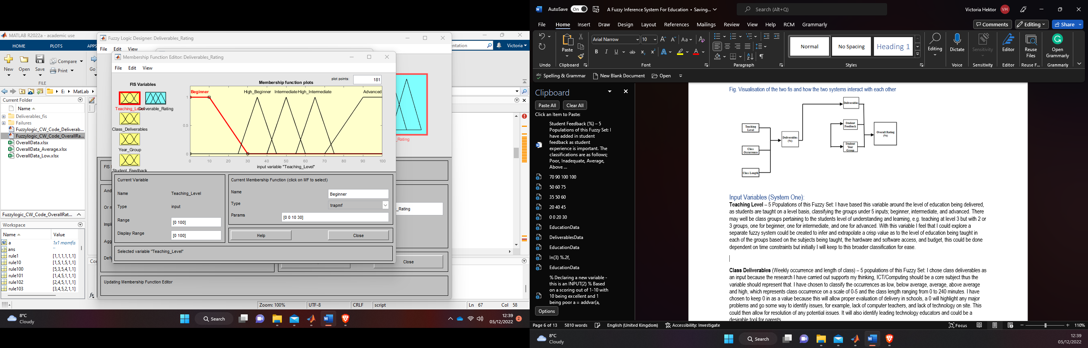

Figure2. Class Deliverables Membership Function

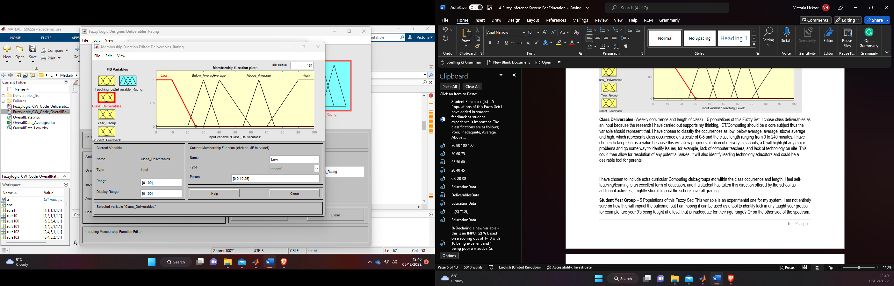

Figure3. Year Group Membership Function

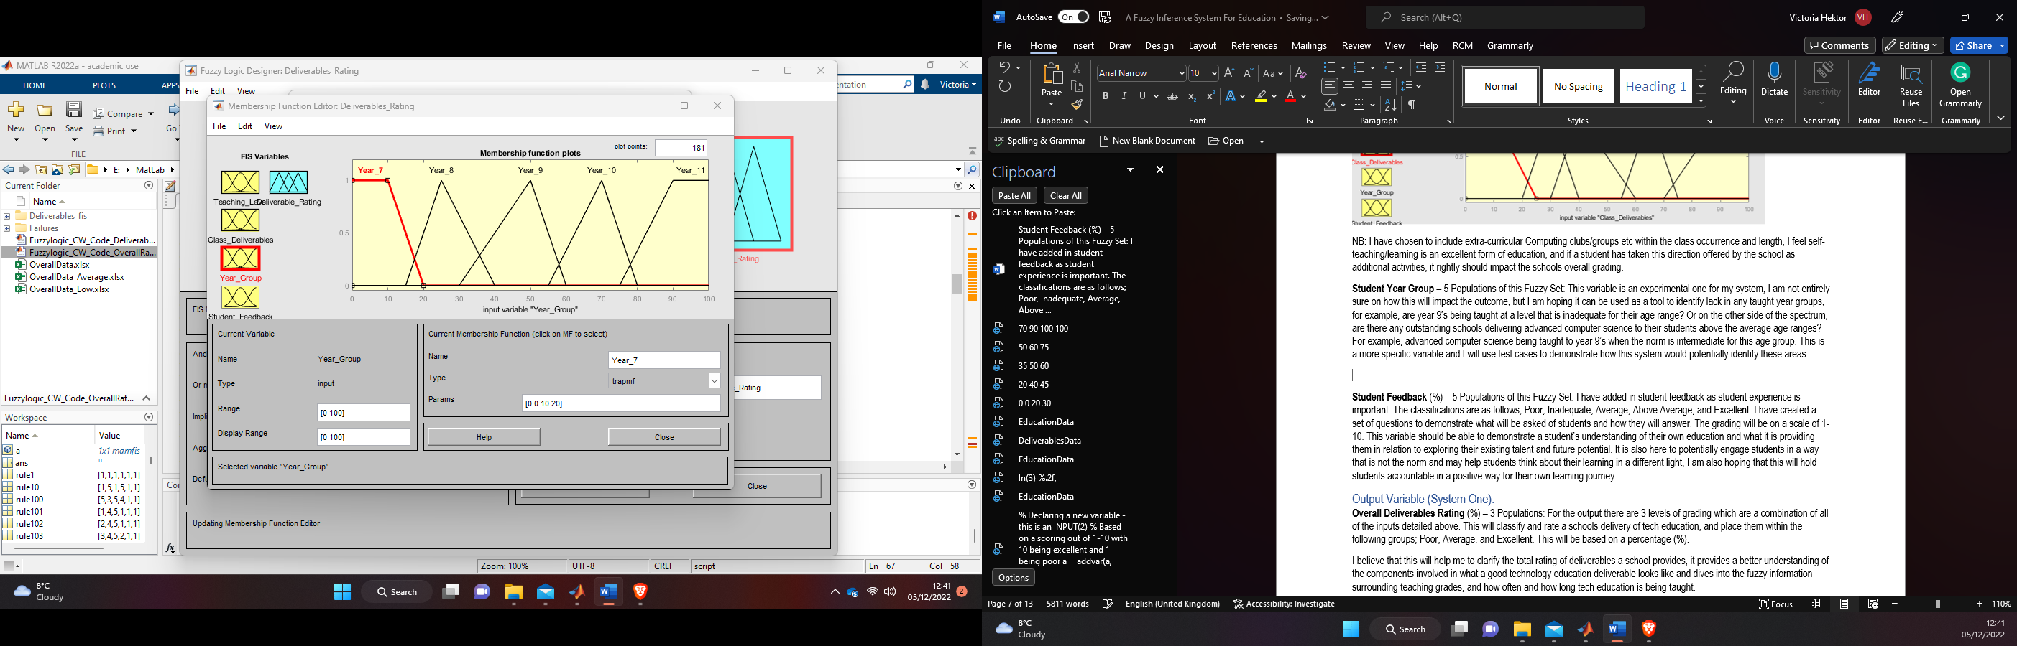

Figure4. Student Feedback Membership Function

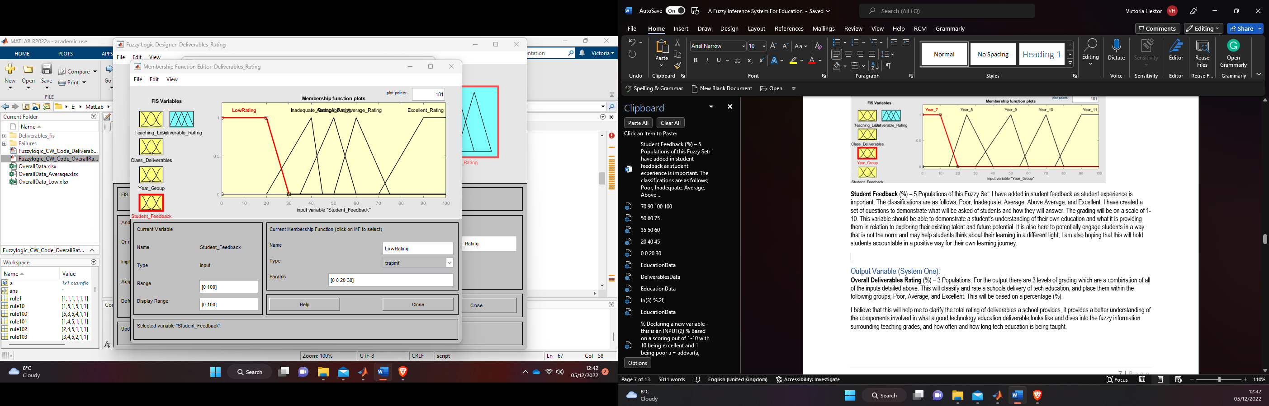

Figure5. Deliverable Rating Output Membership Function

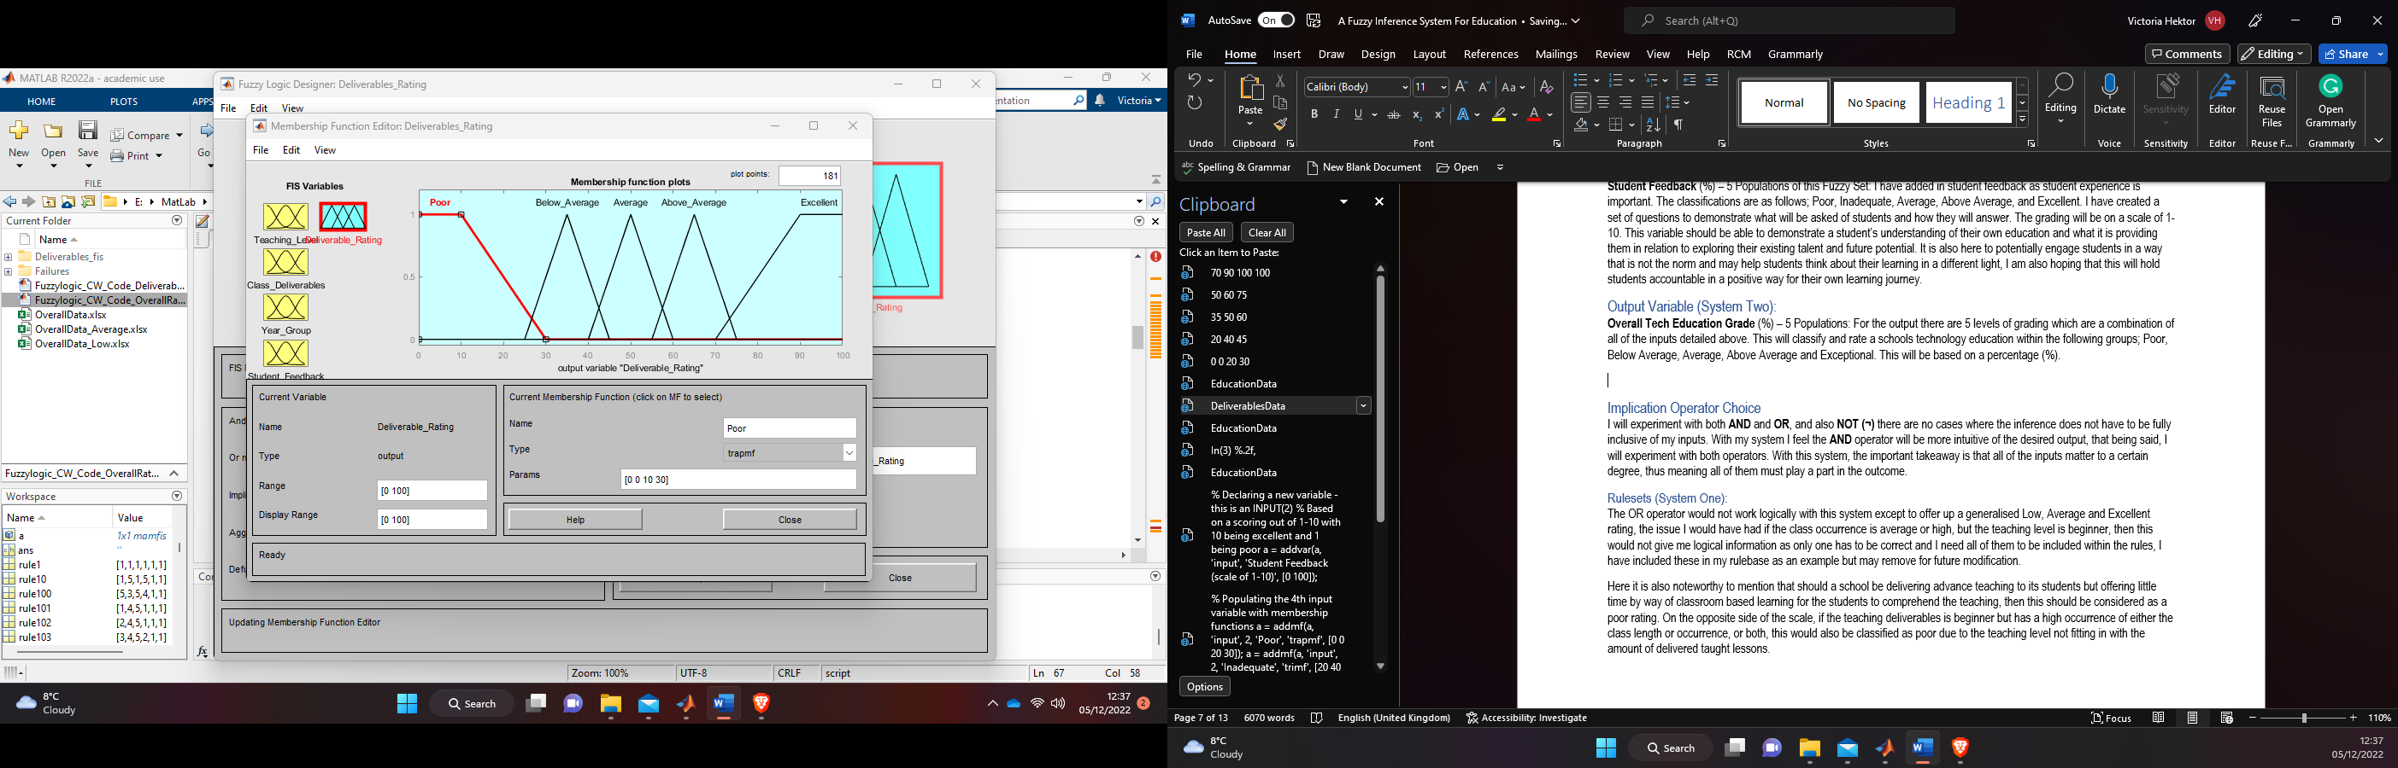

Figure6. Surface Viewer – Year_Group x Class Deliverables = Deliverables Rating:

. 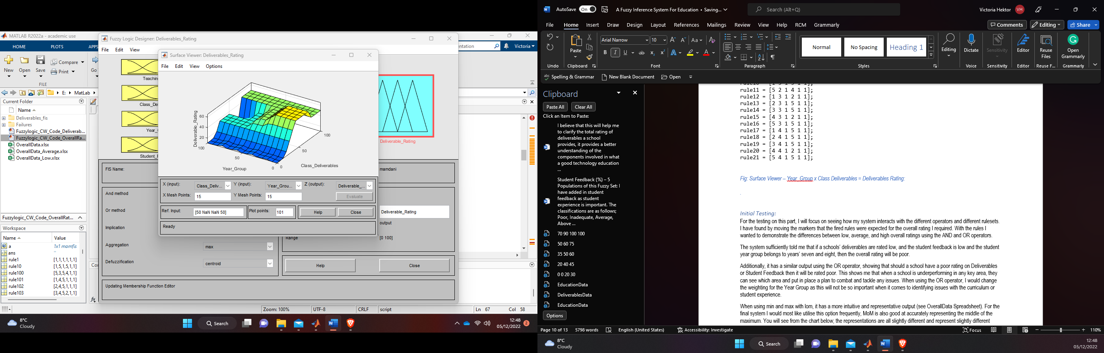

Figure7. Surface Viewer – Year_Group x Teaching_Level = Deliverables Rating:

Figure8. Surface Viewer – Student_Feedback x Class Deliverables = Deliverables Rating:

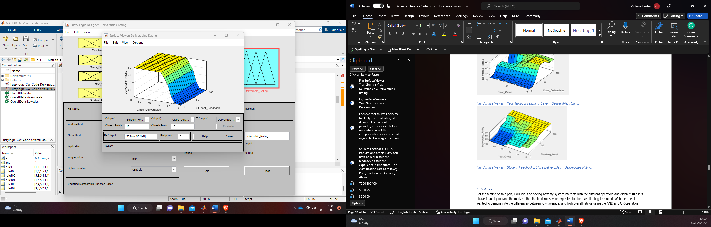

Figure9. Surface Viewer – Student_Feedback x Teaching_Level = Deliverables Rating:

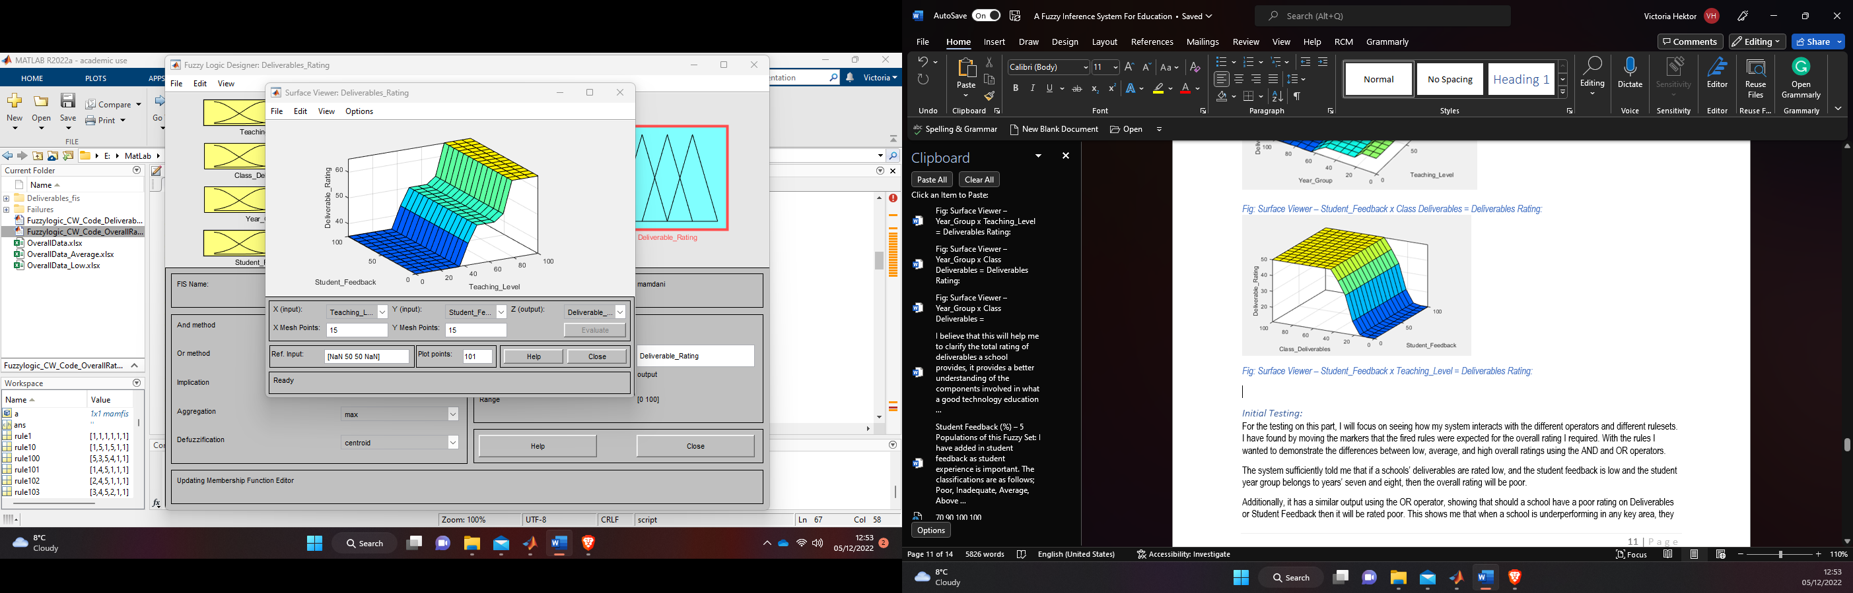

Figure10. Surface Viewer – Student_Feedback x Year_Group = Deliverables Rating:

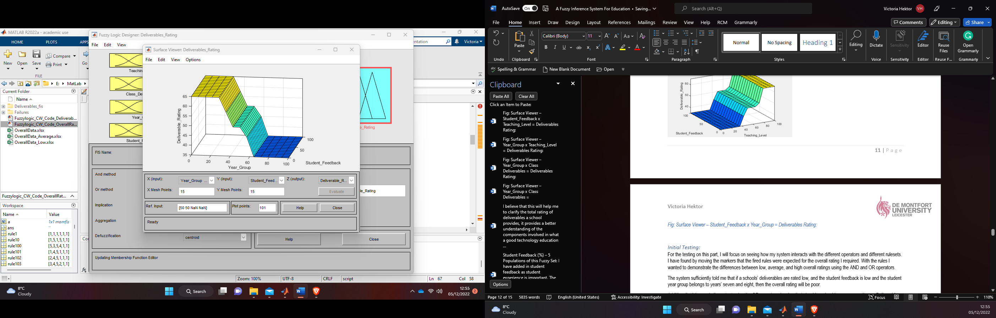

Figure11. Surface Viewer charts for the inputs and output of my fis.

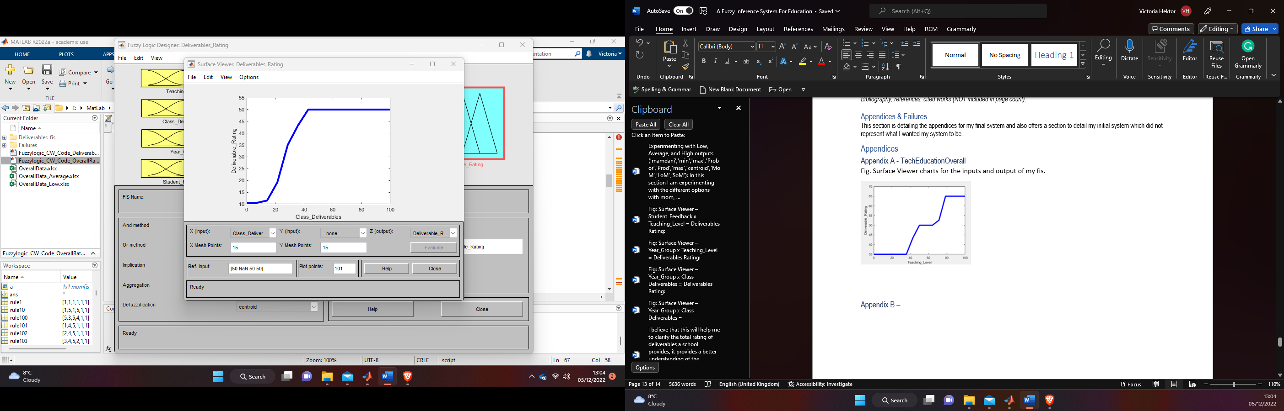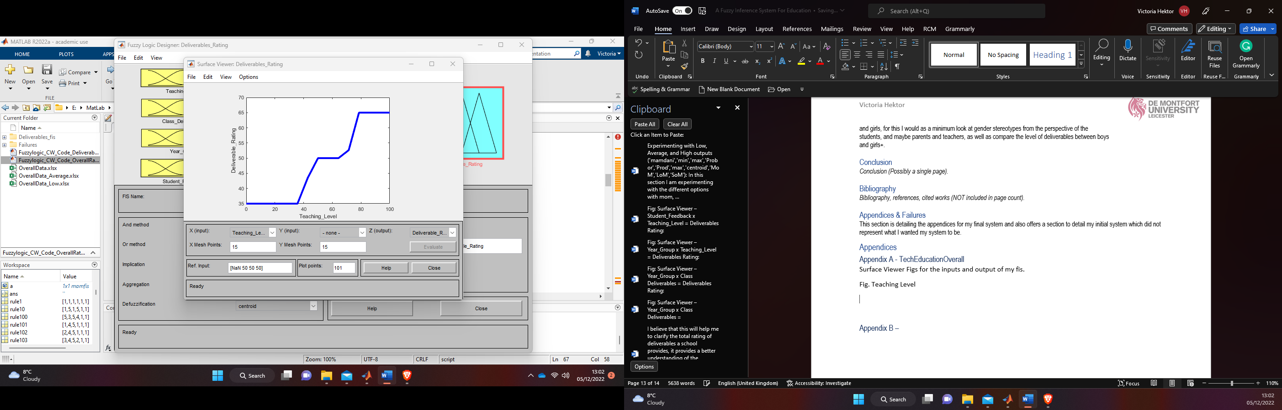

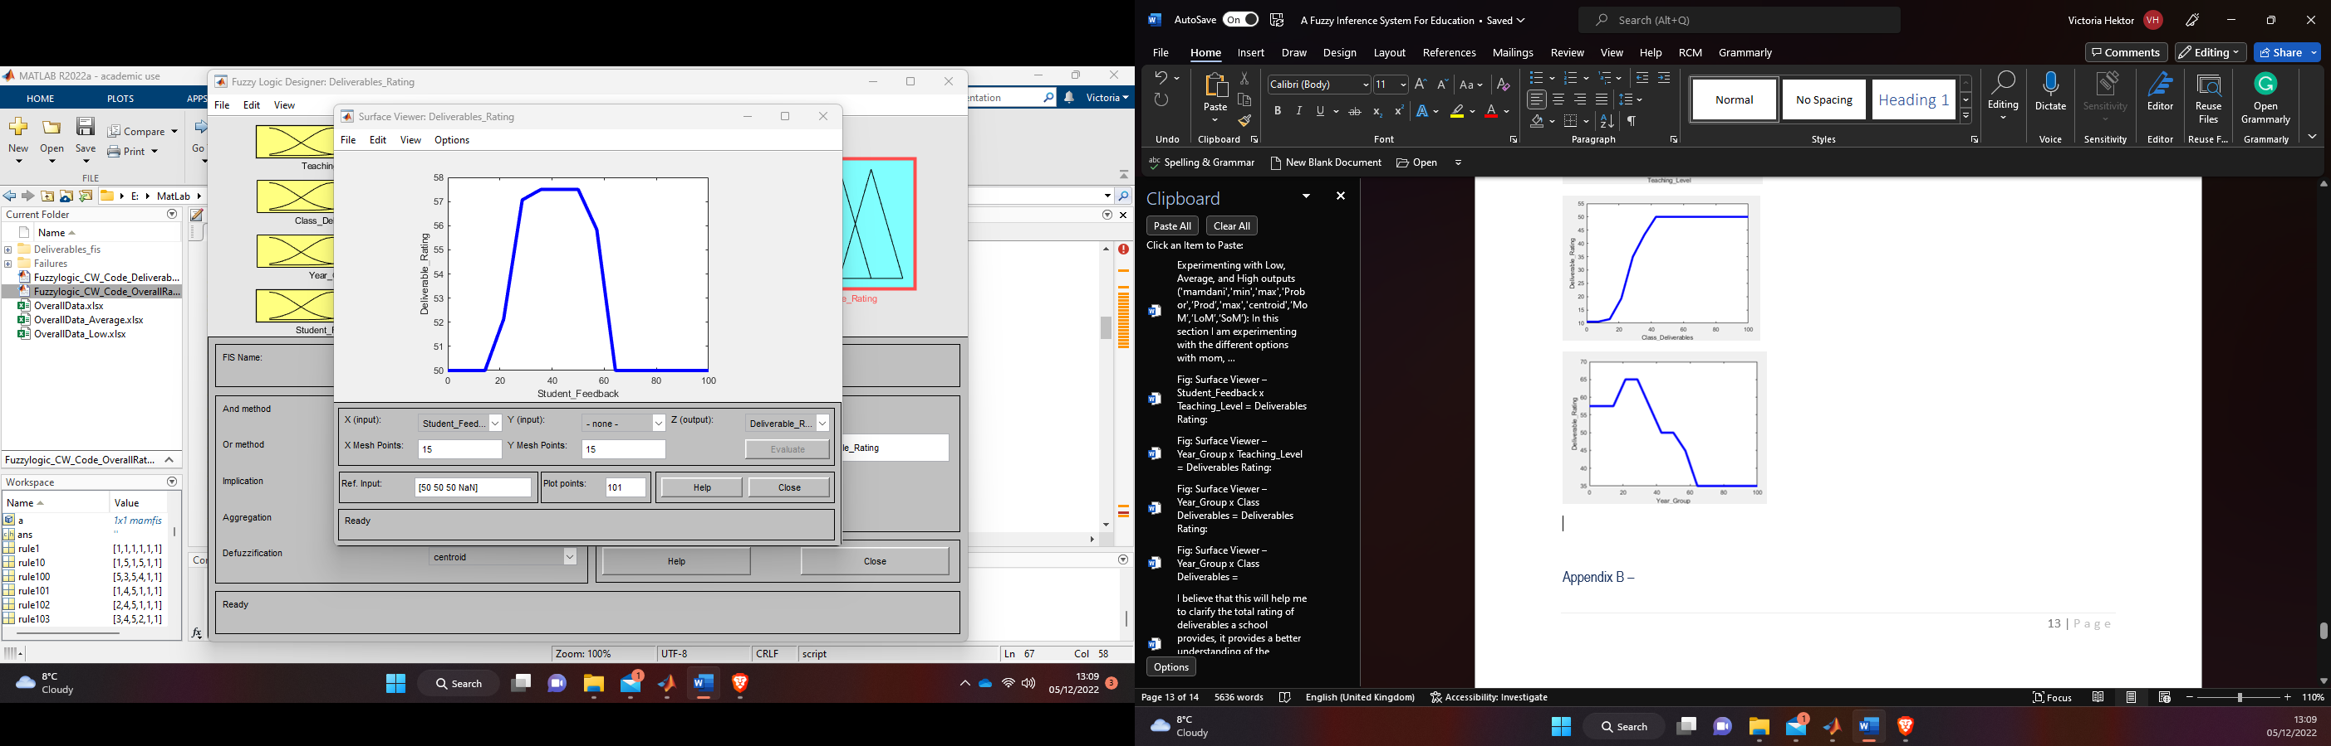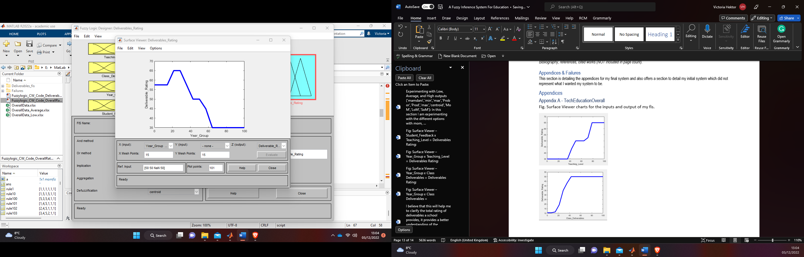

Figure12. Education Rating, as designed using the Fuzzy Designer.

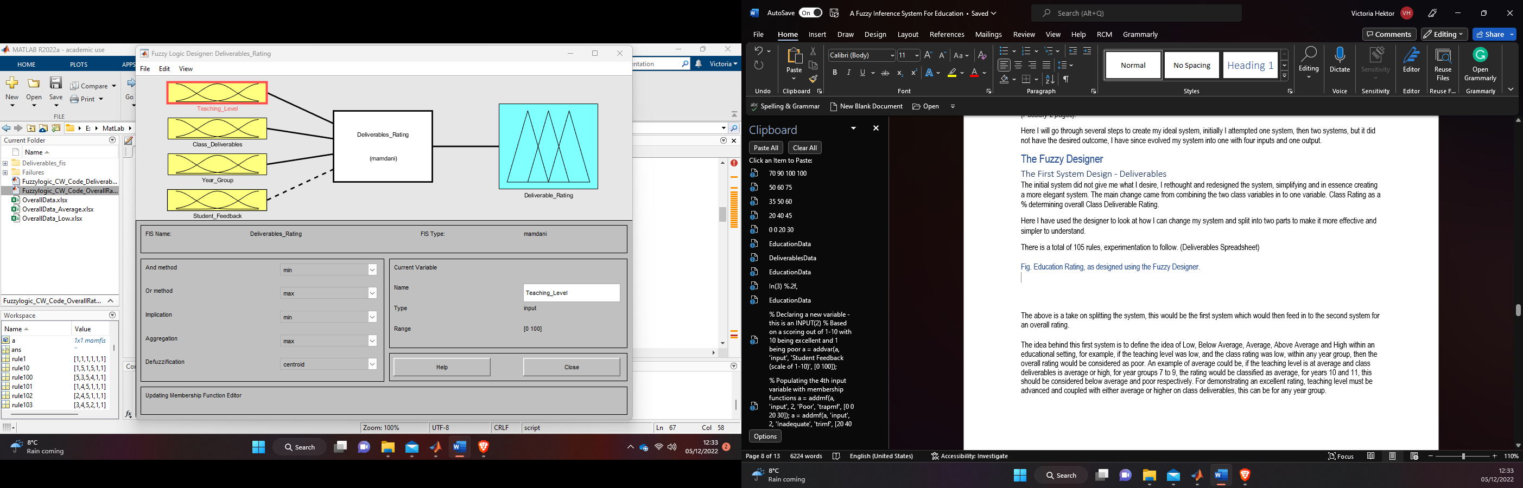

Figure13. Overall Deliverables Rating x Degree of Membership

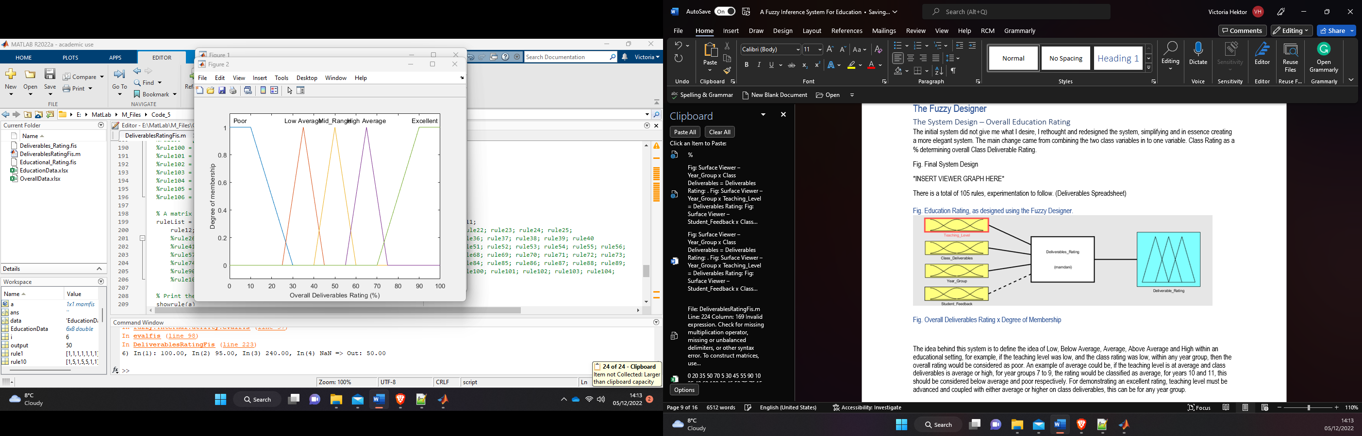

Figure14. Full overview of Inputs and Outputs for my fis

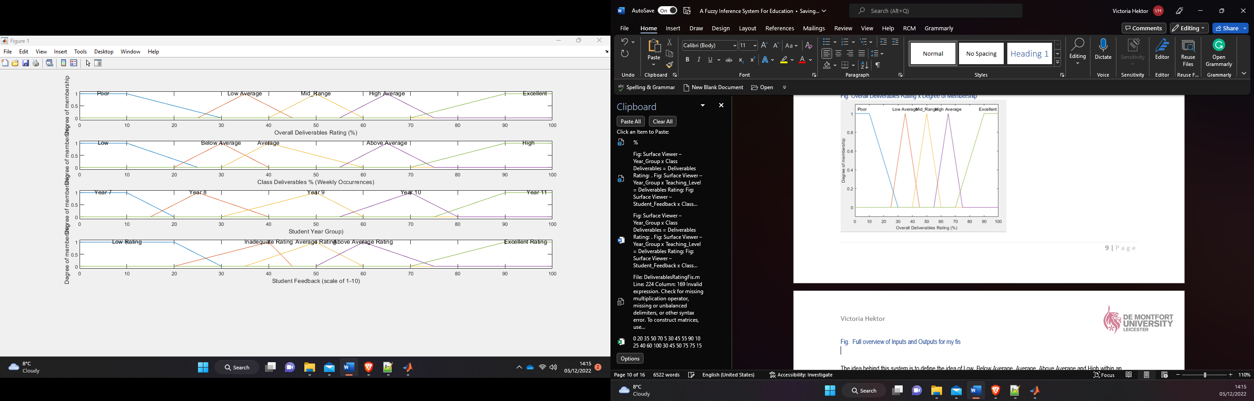

### Appendix B – Rules and Tables

Table3. - Rules for the main chunk of testing

|  |  |  |  |  |
| --- | --- | --- | --- | --- |
| **Poor** | **Below Average** | **Average** | **Above Average** | **Excellent** |
| 1 1 1 1 1 1 1  1 1 1 2 1 1 1  1 2 1 2 1 1 1  3 1 1 2 1 1 1  5 1 1 2 1 1 1  1 1 2 1 1 1 1  1 2 2 2 1 1 1  2 1 2 2 1 1 1  3 1 2 2 1 1 1  5 1 2 2 1 1 1  1 1 3 1 1 1 1  1 2 3 1 1 1 1  2 1 3 2 1 1 1  5 2 3 1 1 1 1  5 1 3 1 1 1 1  1 1 4 1 1 1 1  4 2 4 2 1 1 1  3 1 4 1 1 1 1  3 2 4 1 1 1 1  5 1 4 1 1 1 1  1 1 5 1 1 1 1  1 2 5 2 1 1 1  3 1 5 1 1 1 1  3 2 5 2 1 1 1 | 1 3 1 3 2 1 1  4 2 1 3 2 1 1  4 2 1 3 2 1 1  4 1 1 3 2 1 1  2 3 1 3 2 1 1  2 3 2 3 2 1 1  4 3 2 3 2 1 1  5 3 2 3 2 1 1  5 2 2 3 2 1 1  2 1 2 4 2 1 1  5 2 3 4 2 1 1  2 3 3 4 2 1 1  5 3 3 3 2 1 1  5 2 3 3 2 1 1  2 4 3 3 2 1 1  2 4 4 3 2 1 1  2 3 4 3 2 1 1  5 3 4 3 2 1 1  2 4 4 3 2 1 1  2 2 4 4 2 1 1  2 3 5 4 2 1 1  5 2 5 4 2 1 1  3 3 5 3 2 1 1  2 2 5 4 2 1 1  2 3 5 3 2 1 1 | 1 5 1 5 3 1 1  4 5 1 5 3 1 1  2 5 1 5 3 1 1  4 5 2 5 3 1 1  2 5 2 5 3 1 1  5 5 2 5 3 1 1  2 5 3 5 3 1 1  5 5 3 5 3 1 1  3 5 3 5 3 1 1  5 5 4 5 3 1 1  3 5 4 5 3 1 1  5 5 5 5 3 1 1  3 5 5 5 3 1 1 | 1 2 1 2 4 1 1  4 2 1 2 4 1 1  3 2 1 2 4 1 1  1 2 1 3 4 1 1  1 2 1 3 4 1 1  1 1 2 3 4 1 1  2 2 2 2 4 1 1  3 1 2 2 4 1 1  3 2 2 1 4 1 1  5 1 2 1 4 1 1  5 1 3 1 4 1 1  5 2 3 2 4 1 1  2 2 3 1 4 1 1  3 1 3 2 4 1 1  5 2 3 2 4 1 1  2 3 4 1 4 1 1  5 1 4 1 4 1 1  1 3 4 2 4 1 1  4 2 4 2 4 1 1  3 1 4 1 4 1 1  3 1 5 1 4 1 1  3 2 5 2 4 1 1  2 2 5 2 4 1 1  1 1 5 2 4 1 1  5 2 5 1 4 1 1 | 1 4 1 4 5 1 1  4 4 1 4 5 1 1  2 5 1 4 5 1 1  3 2 1 5 5 1 1  2 4 1 4 5 1 1  2 4 2 4 5 1 1  5 4 2 4 5 1 1  2 3 2 4 5 1 1  4 2 2 5 5 1 1  3 5 2 3 5 1 1  3 5 3 3 5 1 1  5 4 3 3 5 1 1  5 3 3 4 5 1 1  2 3 3 4 5 1 1  2 4 3 4 5 1 1  5 4 4 4 5 1 1  2 4 4 4 5 1 1  3 5 4 3 5 1 1  3 4 4 4 5 1 1  5 3 4 4 5 1 1  3 4 5 4 5 1 1  5 4 5 4 5 1 1  5 3 5 4 5 1 1  2 2 5 5 5 1 1  5 2 5 5 5 1 1 |

Table4. – Rules for further testing all methods

|  |
| --- |
| rule1 = [1 1 1 1 0.2 2];  rule2 = [2 1 2 1 0.4 2];  rule3 = [1 2 2 1 0.6 2];  rule4 = [2 2 2 1 0.8 2];  rule5 = [1 2 1 1 1 2];  rule6 = [1 1 1 1 0.2 1];  rule7 = [2 1 2 1 0.4 1];  rule8 = [1 2 2 1 0.6 1];  rule9 = [2 2 2 1 0.8 1];  rule10 = [1 2 1 1 1 1]; |

Table5. What Ofsted Looks at (Ofsted)

|  |
| --- |
| **What Ofsted Grades:** |
| Effectiveness of Leadership and Management |
| Quality of Teaching, Learning and Assessment |
| Personal Development, Behaviour and Welfare |
| Outcomes for Pupils |
| Early Years Provisions |
| 16-19 Study Programmes |
| Overall Effectiveness |
| Overall Effectiveness at Previous Inspection |

Table6. Ofsted Grading Criteria Breakdown:

|  |  |  |  |
| --- | --- | --- | --- |
| **Quality of Education** | **Behaviour & Attitudes** | **Personal Development** | **Leadership & Management** |
| Intent – Curriculum design, coverage & appropriateness | Attitudes to learning | Spiritual, moral, social, and cultural development | Vision and ethos |
| Implementation – Curriculum delivery, teaching (pedagogy), assessment (formative & summative) | Behaviour | Fundamental British values | Staff development |
|  | Exclusions | Careers guidance | Staff workload & wellbeing |
|  | Attendance | Healthy living & wellbeing | Off-rolling |
|  | Bullying | Citizenship | Governance/oversight |
|  |  | Equality & Diversity | safeguarding |
|  |  | Preparation for the next stage |  |

Table7. – Rules for further testing (AND, OR, Min, Max, Centroid)

|  |  |
| --- | --- |
| rule1 = [1 1 1 1 1 1 1];  rule2 = [1 2 2 2 1 1 1];  rule3 = [1 1 2 1 1 1 1];  rule4 = [1 1 3 1 1 1 1];  rule5 = [2 1 5 1 1 1 1];  rule6 = [4 2 4 2 1 1 1];  rule7 = [1 3 1 3 2 1 1];  rule8 = [3 3 5 3 2 1 1];  rule9 = [2 3 2 3 2 1 1];  rule10 = [2 3 3 3 2 1 1];  rule11 = [5 4 4 3 2 1 1];  rule12 = [2 3 2 3 2 1 1];  rule13 = [4 5 1 5 3 1 1];  rule14 = [2 5 2 5 3 1 1];  rule15 = [5 5 2 5 3 1 1];  rule16 = [5 5 3 5 3 1 1]; | rule17 = [5 4 3 5 3 1 2];  rule18 = [3 5 5 5 3 1 1];  rule19 = [2 2 1 2 4 1 1];  rule20 = [3 1 2 2 4 1 1];  rule21 = [4 2 2 2 4 1 1];  rule22 = [4 2 3 3 4 1 1];  rule23 = [4 2 4 2 4 1 1];  rule24 = [5 1 5 2 4 1 1];  rule25 = [2 3 2 4 5 1 1];  rule26 = [4 3 1 3 5 1 1];  rule27 = [2 3 2 4 5 1 1];  rule28 = [5 4 3 4 5 1 2];  rule29 = [5 3 3 4 5 1 1];  rule30 = [5 4 4 4 5 1 1];  rule31 = [5 4 5 4 5 1 1];  rule32 = [3 4 4 5 3 1 1]; |

### Appendix C – Testing

Figure15. Excel Depiction of Year Group 7 Testing

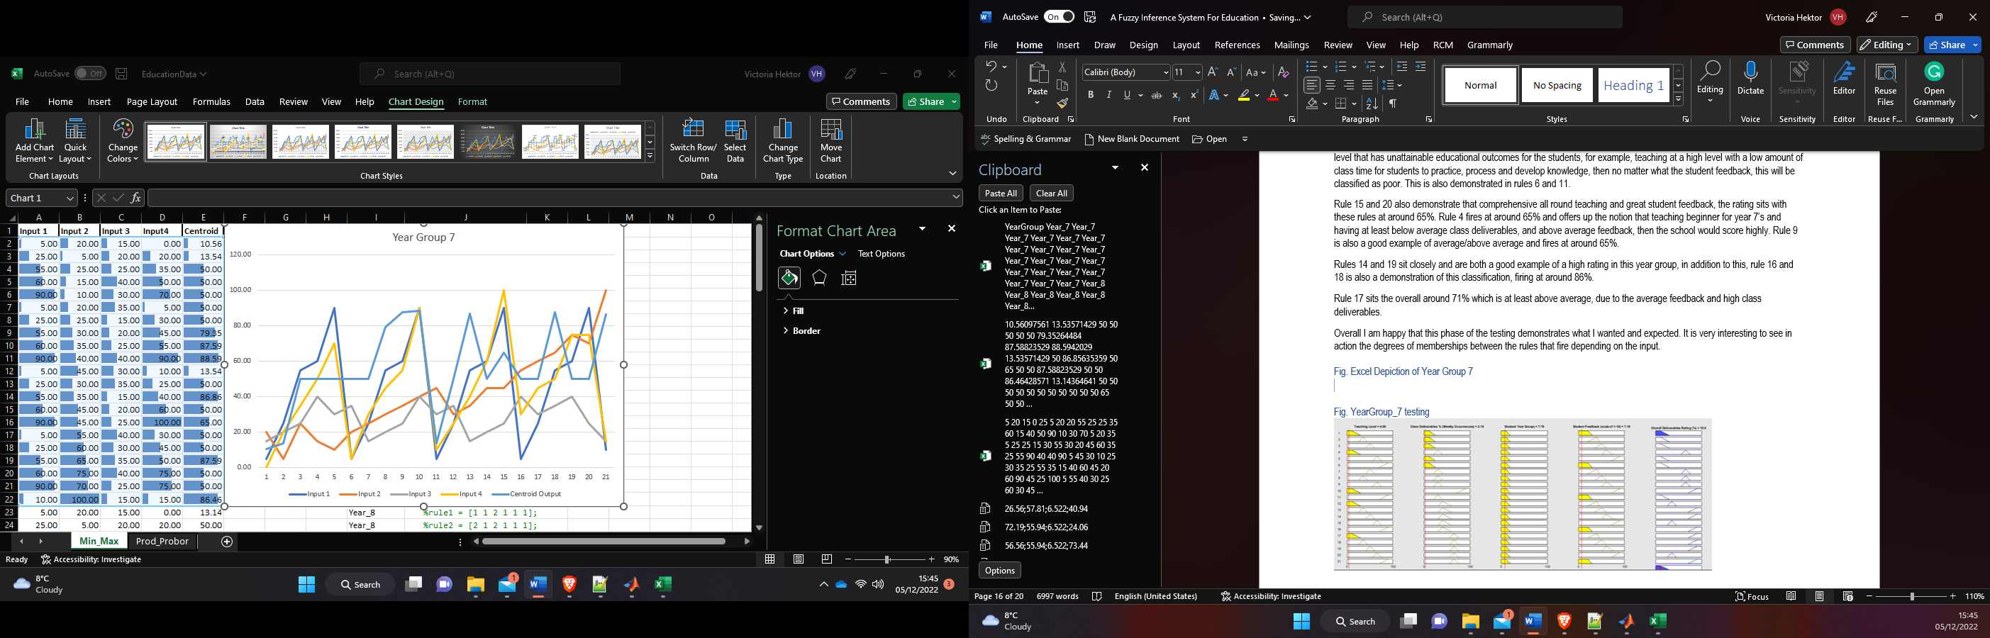

Figure16. Poor Rating Ruleset Graph – Min, Max

Figure17. Poor Rating Ruleset Graph – Prod, Probor

Figure18. Complete overall graph depicting all initial testing on my first system.

Figure19. 12-14% Bisector, Centroid & MoM Output, Min, Max

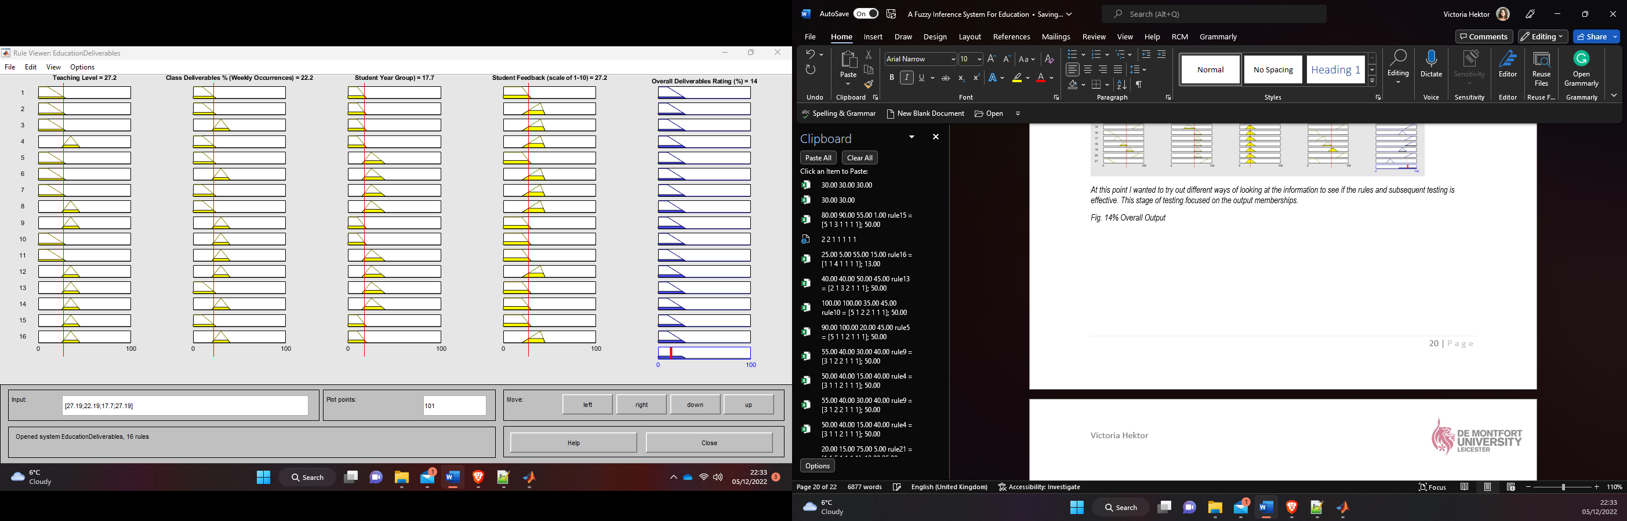

Figure20. LoM Output, Min, Max

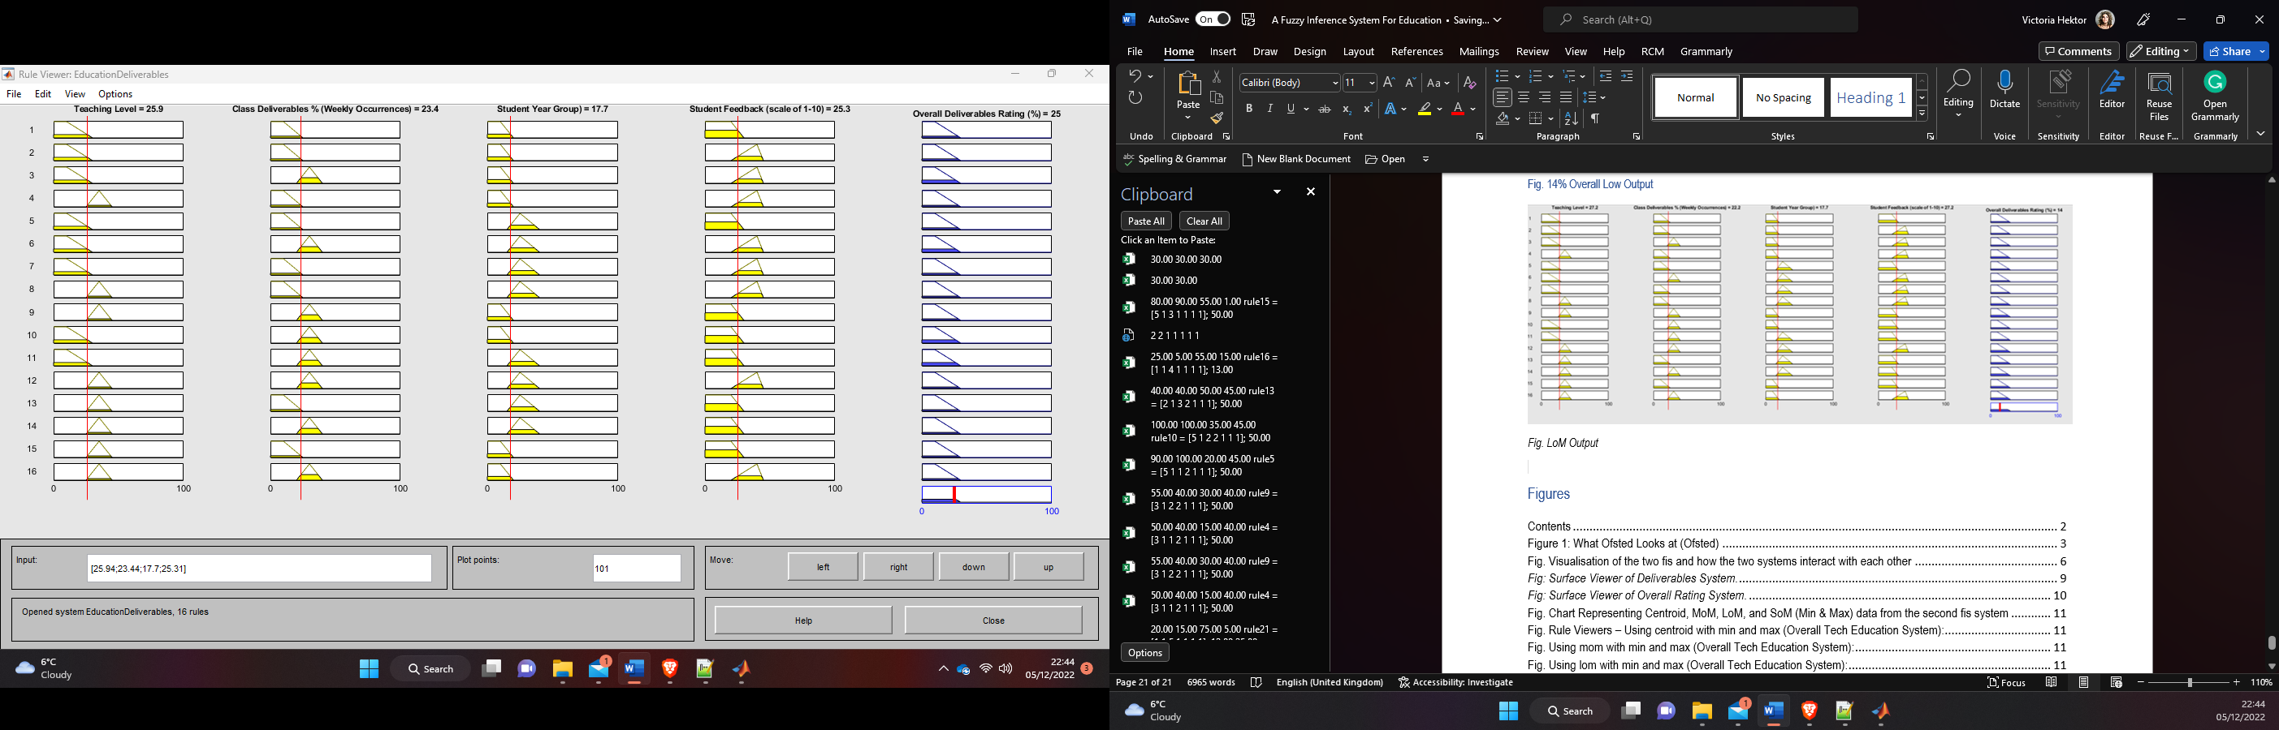

Figure21. SoM Output, Min, Max

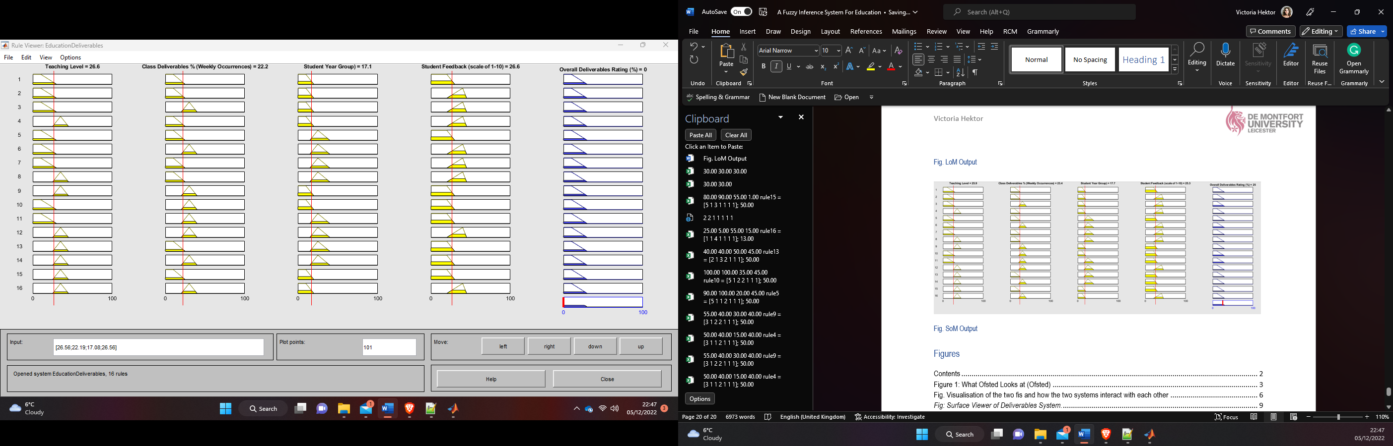

Figure22. Centroid – Prod, Probor

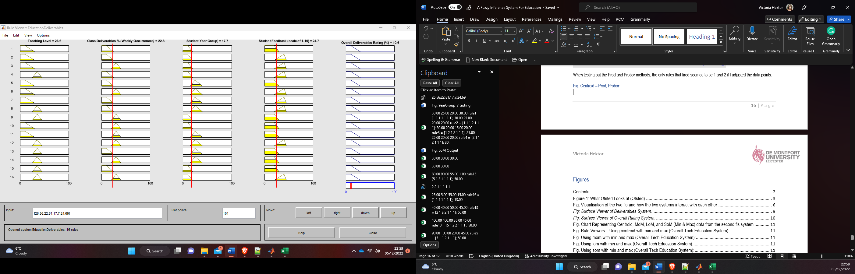

Figure23. MoM – Prod, Probor

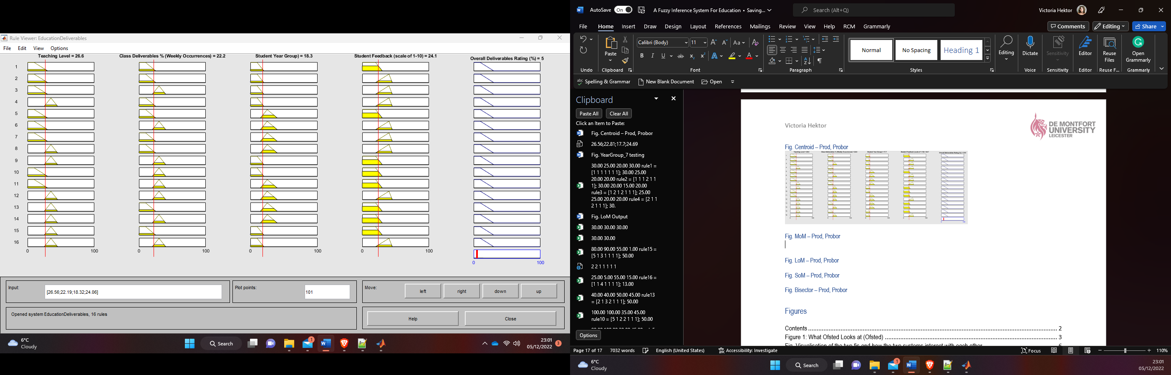

Figure24. LoM – Prod, Probor

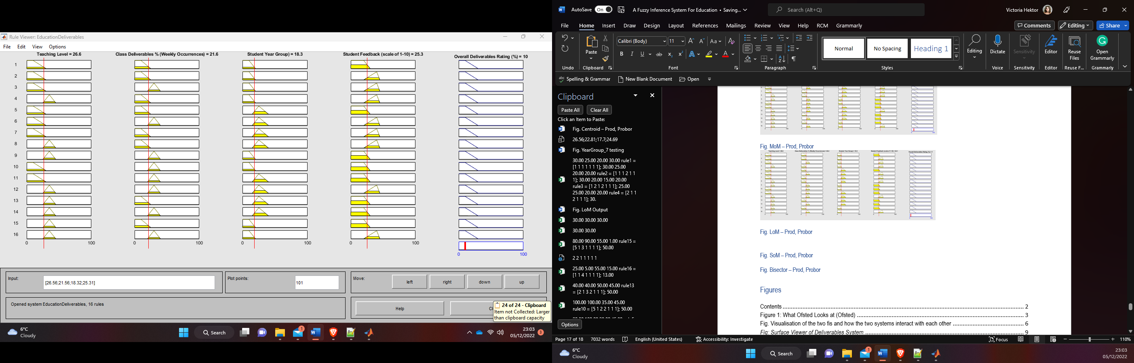

Figure25. SoM – Prod, Probor

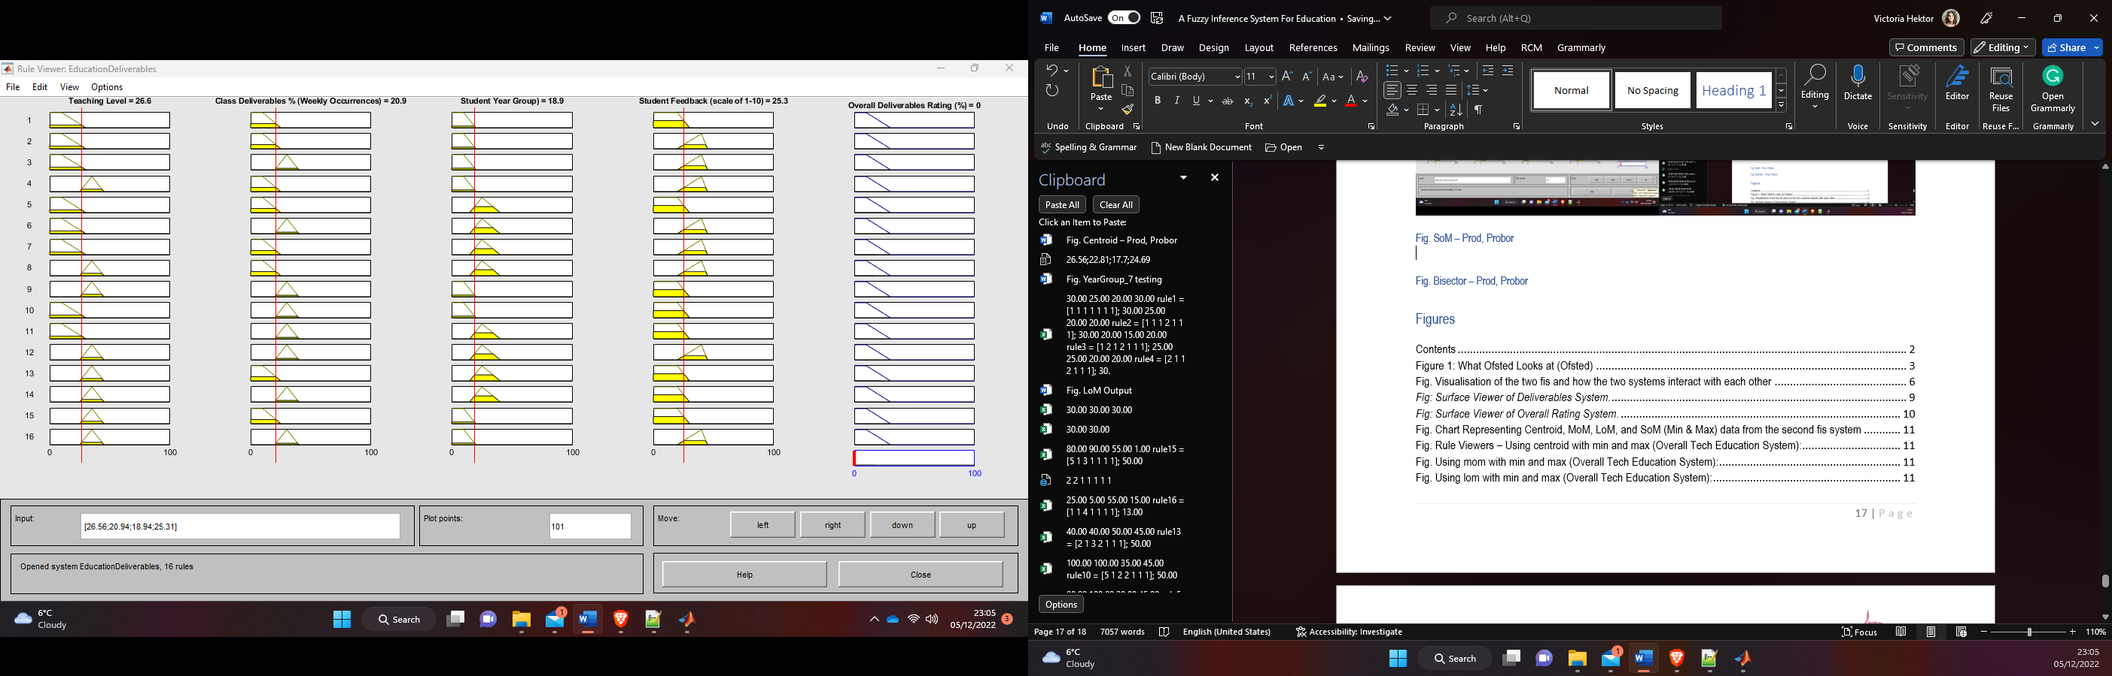

Figure26. Bisector – Prod, Probor

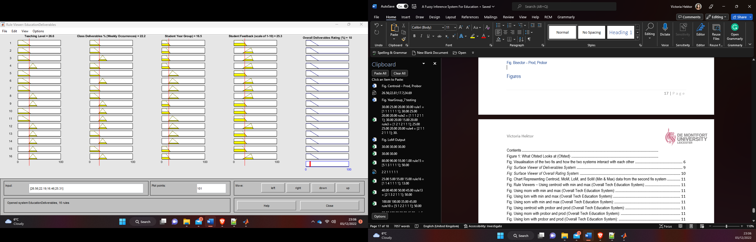

Figure27. Additional Testing Outcome

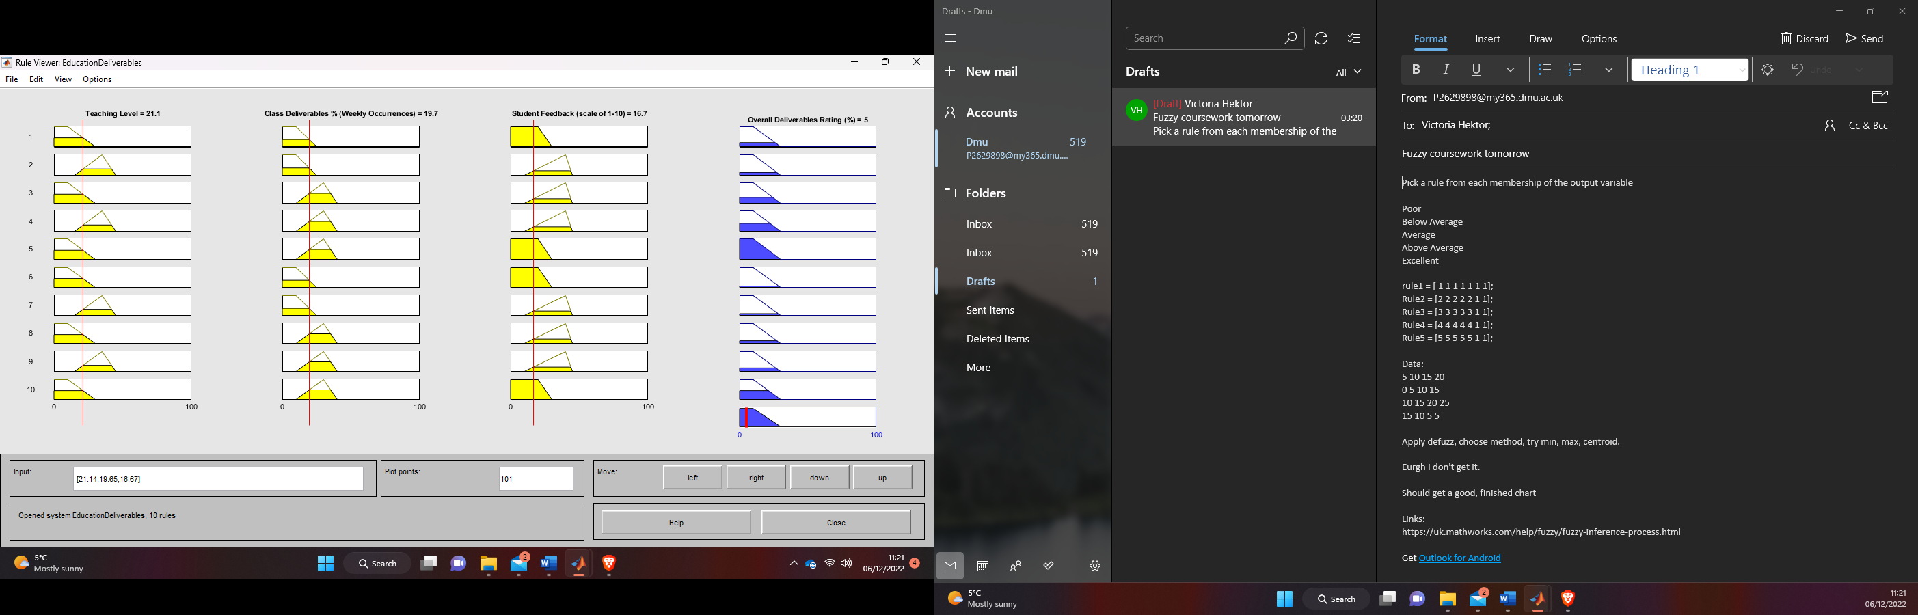

Figure28. Final Overall Testing – Low Groups (21%)

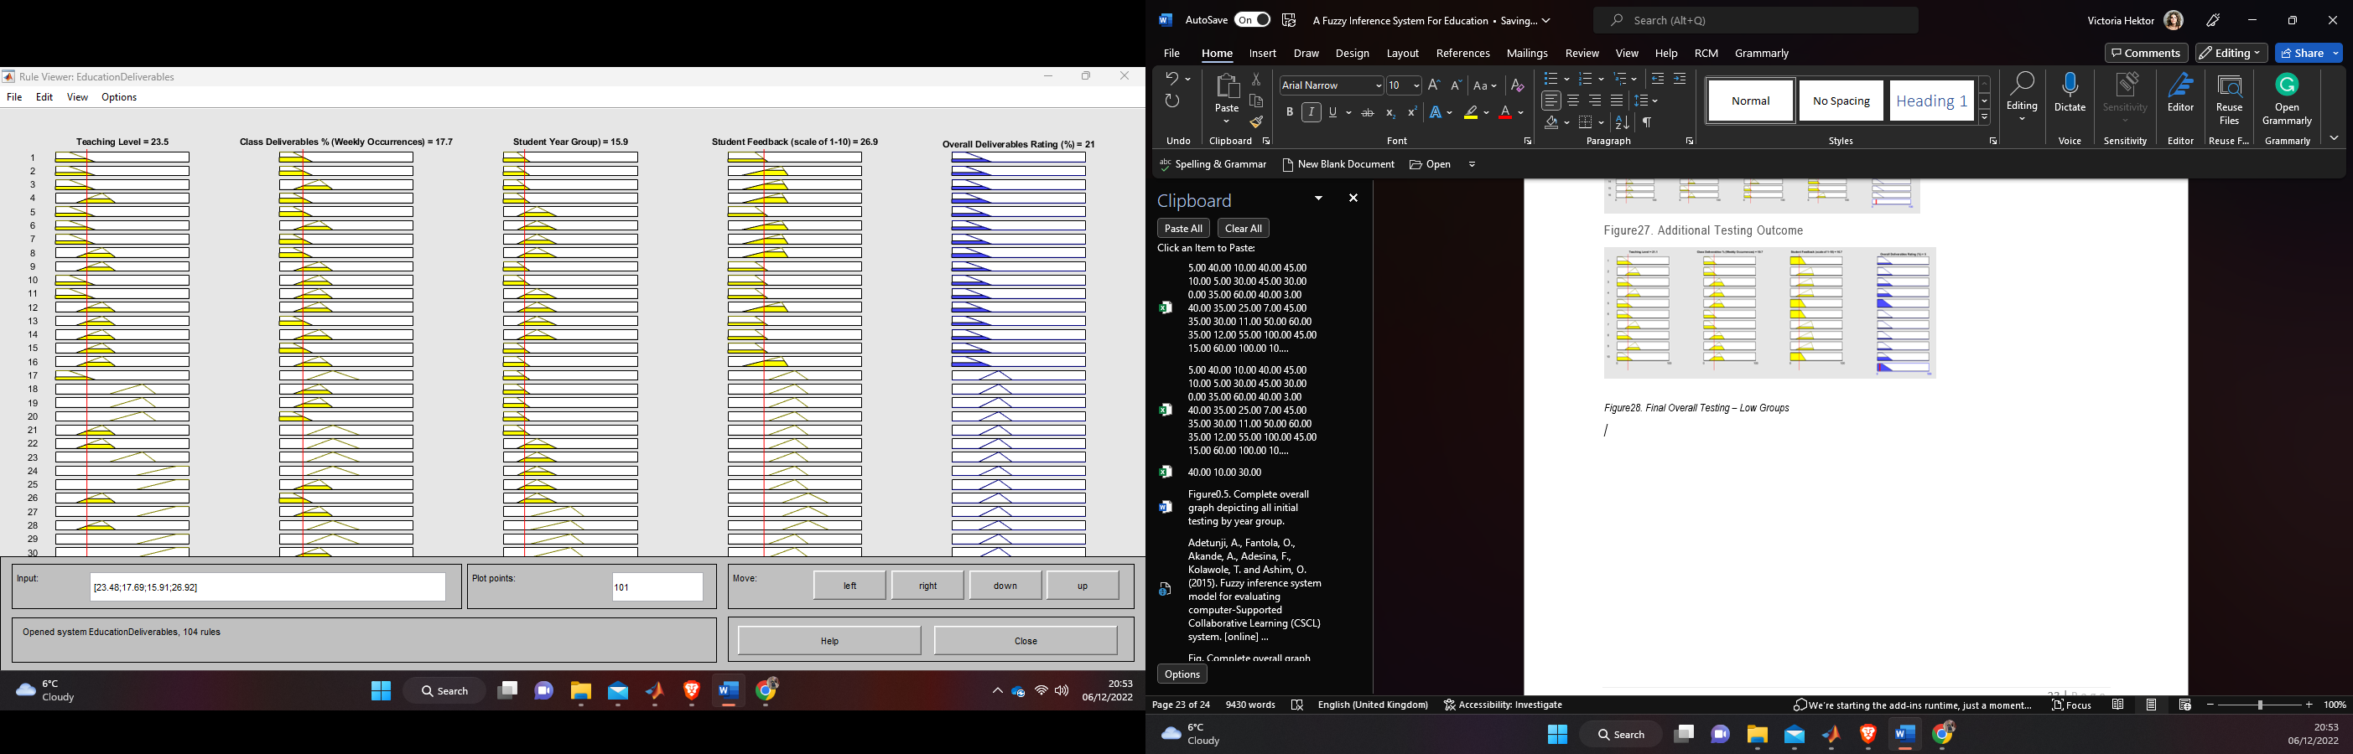

Figure29. Final Overall Testing – 10 Rules (57%)

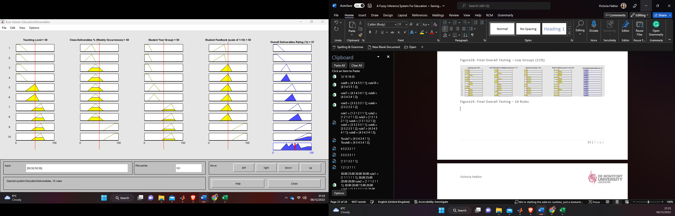

Figure30. Final Overall Testing – 10 Rules (35%)

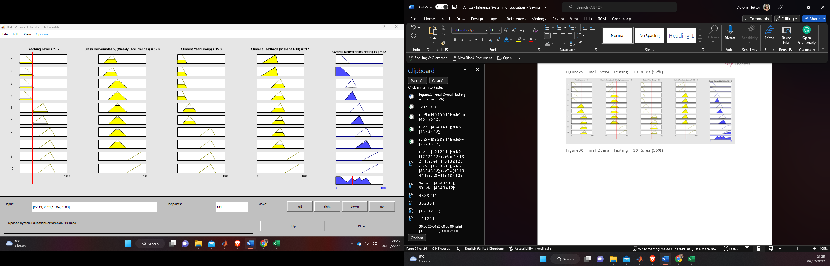

Figure31. Final Overall Testing – 10 Rules (76%)

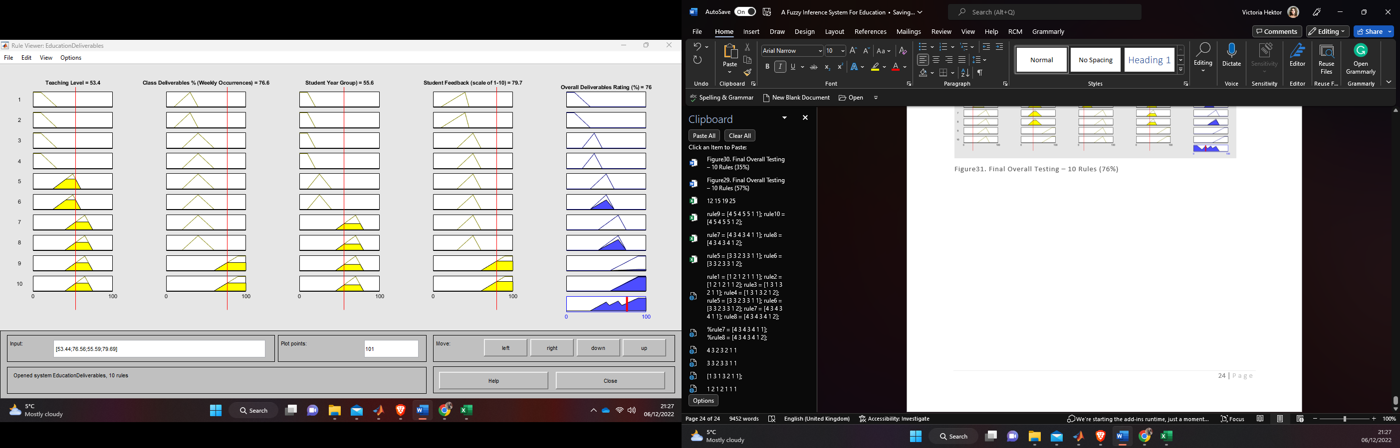

Figure32. Final Overall Testing – 10 Rules, Min, Max, Centroid (46.2%)

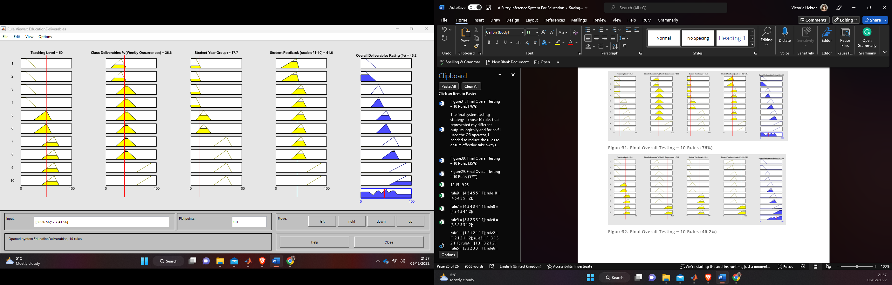

Figure33. Final Overall Testing – 10 Rules, Min, Max, MoM (95%)

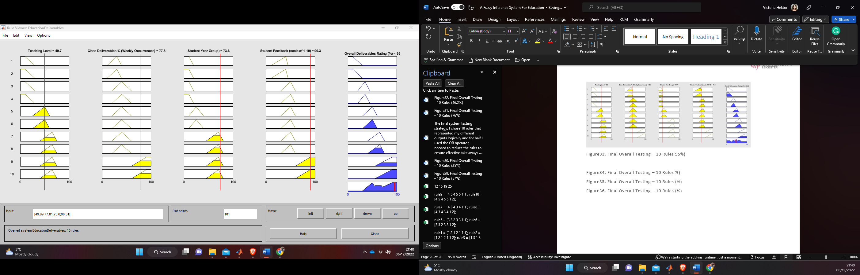

Figure34. Final Overall Testing – 10 Rules Min, Max, LoM 65%)

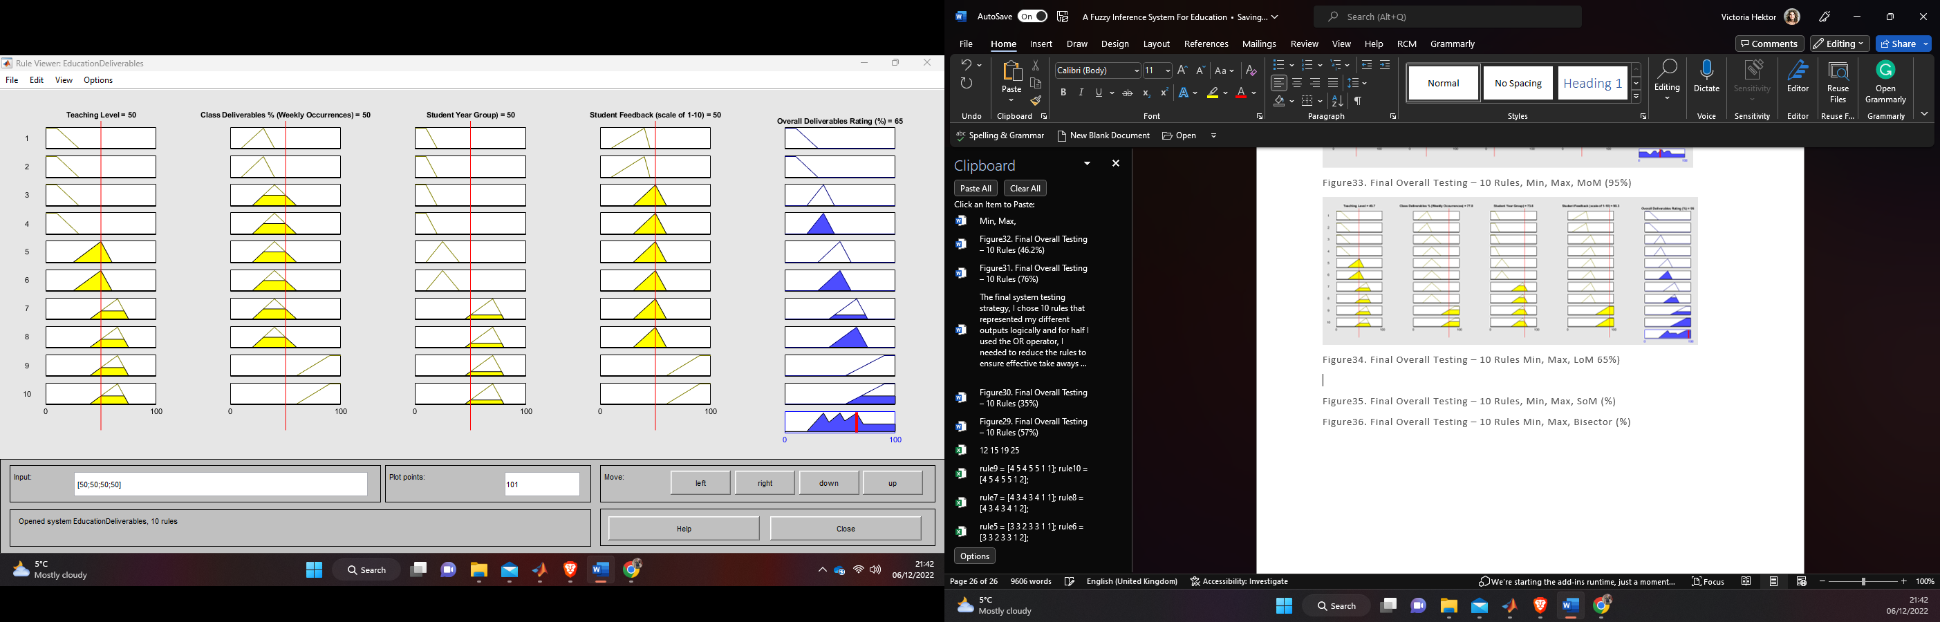

Figure35. Final Overall Testing – 10 Rules, Min, Max, SoM (50%)

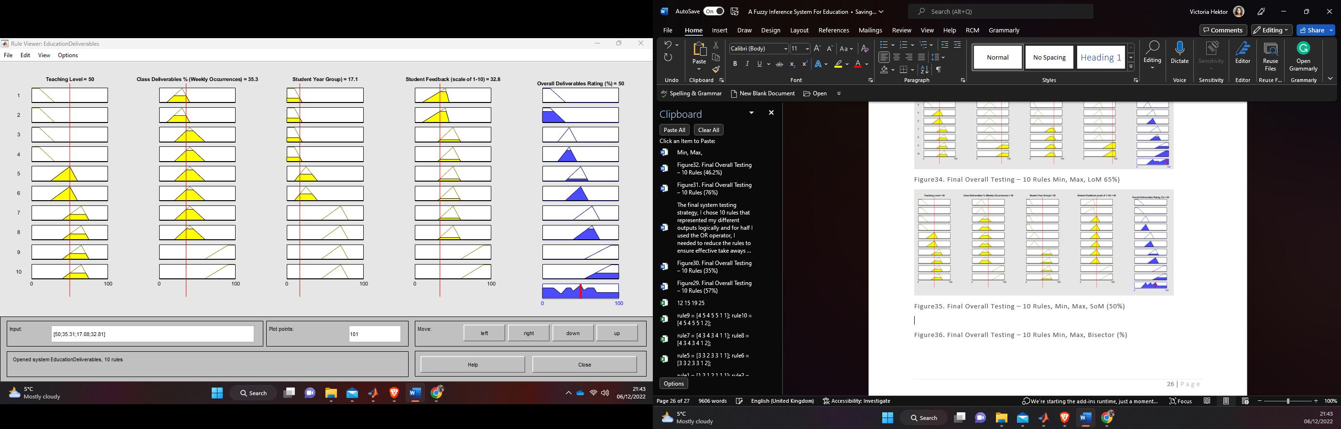

Figure36. Final Overall Testing – 10 Rules Min, Max, Bisector (54%)

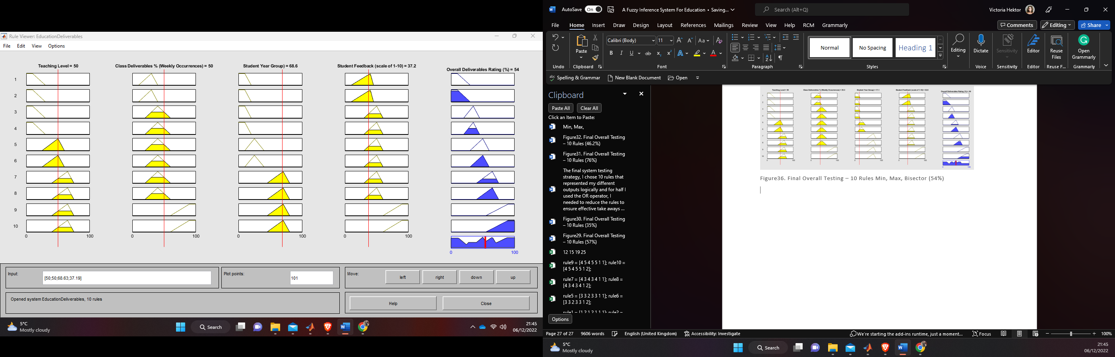

Figure37. Final Overall Testing – 32 Rules: Min, Max, Centroid

Figure38. Final Overall Testing – 32 Rules: Min, Max, MoM

Figure39. Final Overall Testing – 32 Rules: Min, Max, LoM

Figure40. Final Overall Testing – 32 Rules: Min, Max, SoM

Figure41. Final Overall Testing – 32 Rules: Min, Max, Bisector

Figure42. Centroid – **Cen**tre of an object MOM, SOM, and LOM stand for middle, smallest, and largest of maximum (Output Representation)